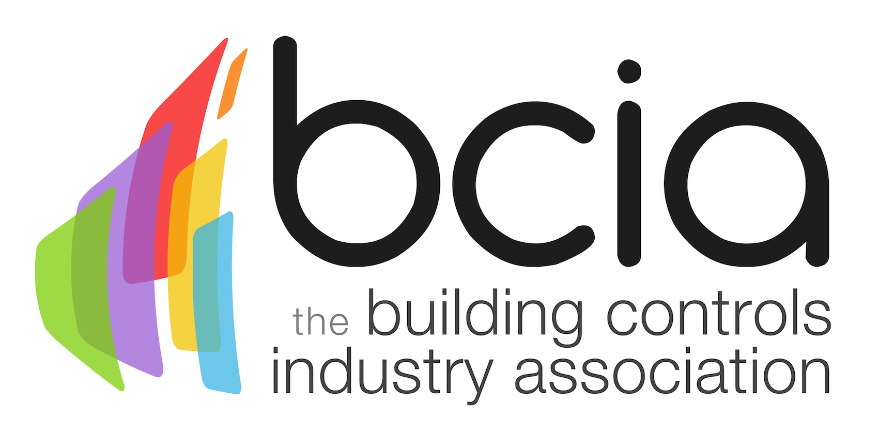

Press Release

2 March 2017

2017 BCIA Awards finalists announced

The BCIA are delighted to have received a record number of entries for the 2017 BCIA Awards, showing an increased standard of excellence across the entire industry. Such high calibre entries presented the team of independent judges with a difficult task, after much deliberation the finalists were decided on as follows:

Independent Building Controls & BEMS Installer of the Year
Sponsored by CentraLine by Honeywell
Associated Technology Services
AES Control Systems
Chartwell Controls
Comfort Controls
Eton Associates
Global Associates

Best Service & Maintenance Provider
Sponsored by Western Automation
AIS BMS
BG Energy Solutions
Building Management Solutions Integrators (BMSI)
Comfort Controls
Kendra Energy Solutions
SSE Enterprise Energy Solutions

Technical Innovation of the Year - Projects
Sponsored by Johnson Controls
Sheffield Hallam University – Comfort Controls
The City of Glasgow College – Enterprise Controls
Cavendish Close Junior School – Integrated BMS
The City of Edinburgh Council – SSE Enterprise Energy Solutions

Technical Innovation of the Year - Products
Sponsored by Modern Building Services
New Butterfly Valves and PR actuators – Belimo Automation UK
Aspect – Cylon Controls
CentraLine by Honeywell ROOMUP App
BI Metrics – Priva UK
Desigo CC – Siemens Building Technologies
ECLYPSE Connected Terminal Unit Controller – Distech Controls

Energy Management Award
Sponsored by Priva
QinetiQ-Blended PPM, Support and Energy Engineering Contract – BMSI
Financial Times building – Chartwell Energy Solutions
The Sainsbury Laboratory, Cambridge - Chartwell Energy Solutions
Vue Cinemas – BG Energy Solutions

Contribution to Training Award
Sponsored by Siemens Building Technologies
Eton Associates
One Sightsolutions
The Sontay Academy

Engineer of the Year
Sponsored by Trend Control Systems
Stephen Astwood – Johnson Controls
Rafal Kapela – Chartwell Controls
Bradley Mackfall – InTandem Systems
Paul Mitchell – Kendra Energy Solutions
Albert Ndongala – BMSI
Darren Willis – Comfort Controls

Young Engineer of the Year
Sponsored by BCIA
George Belfield – InTandem Systems
Laurence Olney – BMSI
Leo Pesci – Kendra Energy Solutions
James Rees – System Five

Malcolm Anson, President of the BCIA says: “There were so many remarkable entries to judge this year, showing our industry continues to go from strength to strength. I would urge everyone to join us at this year’s awards ceremony to celebrate the best of the best in the building controls industry.”
The most prestigious event in the building controls calendar will take place on Thursday 11 May 2017 at the Hilton Metropole in Birmingham. Don’t miss out on your chance to see who this year’s winners will be. Book your place now at www.bcia.co.uk

Note to editors
The Building Controls Industry Association (BCIA) represents the UK building controls and BEMS sector. With around 75 members accounting for 70% of the UK controls market, the BCIA is an influential group that promotes better specification, application and use of controls. The BCIA also offers its own training courses and the Building Controls Professional Assessment (BCPA).

For further information about the BCIA please contact Keystone Communications:

Tracey Rushton-Thorpe
Tel: 01733 294524
Email: tracey@keystonecomms.co.uk

Leanne Elliott
Tel: 01733 294524
Email: leanne@keystonecomms.co.uk

