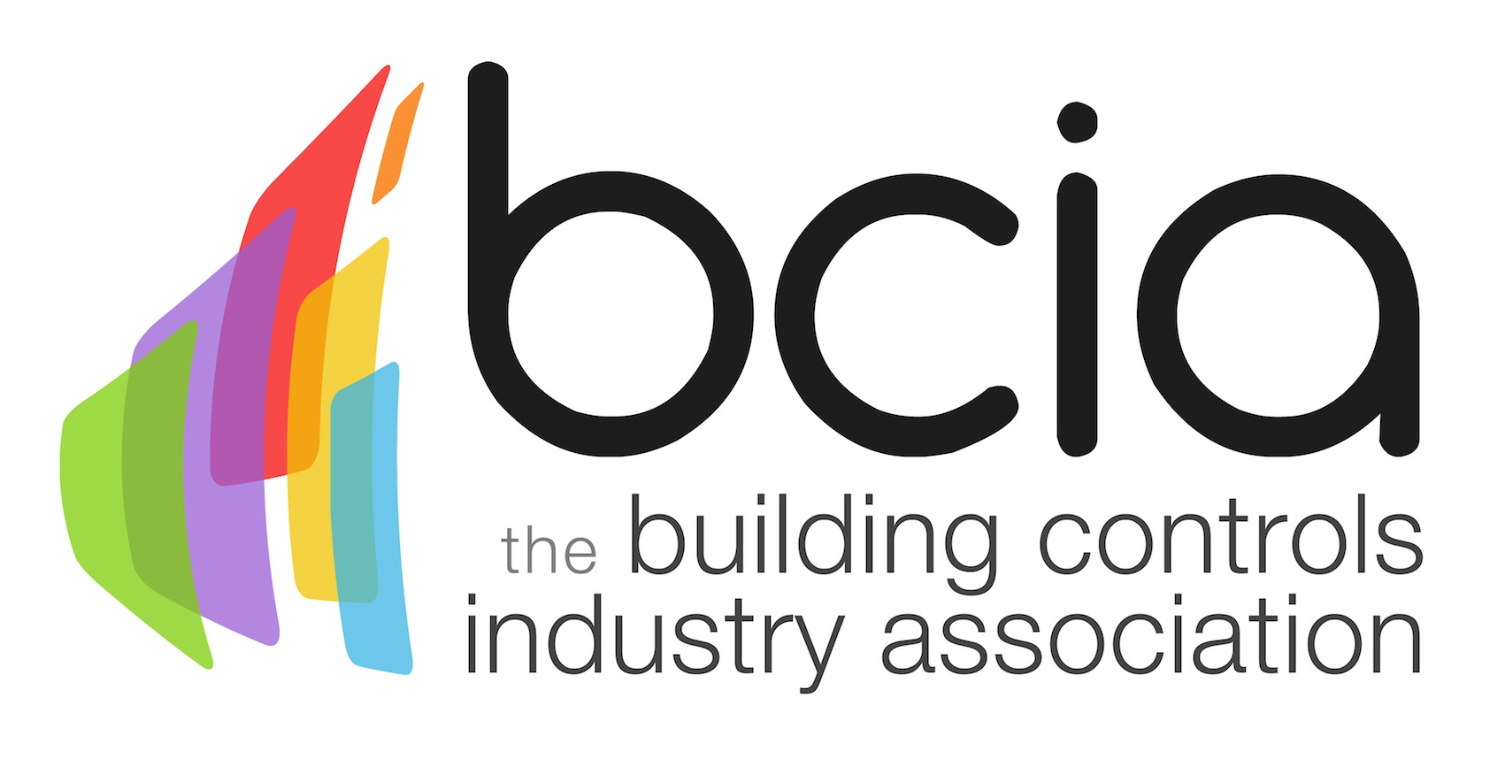

Press Release

14 February 2017

Steph McGovern to host BCIA Awards

Tickets are now on sale for the 2017 Building Controls Industry Association (BCIA) Awards which will be hosted by award winning broadcaster Steph McGovern.

Steph McGovern has been involved in financial journalism for over 13 years and is well known for her work on BBC Breakfast. In her work for the BBC, Steph covers economic and business news, making it her priority to share what is going on in the real economy. At the age of 19 Steph won the title of Young Engineer for Britain after saving Black & Decker more than £1m on a design she did for their Leaf Hog product.

Malcolm Anson, President of the BCIA says: “We are delighted to have such a high profile personality, Steph McGovern joining us at this year’s awards. Steph’s professionalism and knowledge, as well as links to industry will make her the perfect host for what promises to be an enjoyable evening.

“The atmosphere at past awards has always been amazing, you can feel the anticipation building as the finalists and winners are announced, followed by cheers of delight, showing we are all truly dedicated and proud of what we do. Whether you are a winner or not, you are guaranteed an enjoyable night.”

The prestigious awards ceremony and gala dinner will take place on Thursday 11 May 2017 at the spectacular setting of the Hilton Birmingham Metropole. Tickets include a three course dinner, the awards ceremony, post show entertainment and networking with peers, press, friends and colleagues.

A table of ten costs only £1,000.00 and individual places are available for £120.00 (all prices exclude VAT). To book your places please visit the BCIA website and download a booking form, www.bcia.co.uk.

www.bcia.co.uk

Note to editors
The Building Controls Industry Association (BCIA) represents the UK building controls and BEMS sector. With around 75 members accounting for 70% of the UK controls market, the BCIA is an influential group that promotes better specification, application and use of controls. The BCIA also offers its own training courses and the Building Controls Professional Assessment (BCPA).

For further information about the BCIA please contact Keystone Communications:

Tracey Rushton-Thorpe
Tel: 01733 294524
Email: tracey@keystonecomms.co.uk

Leanne Elliott
Tel: 01733 294524
Email: leanne@keystonecomms.co.uk

