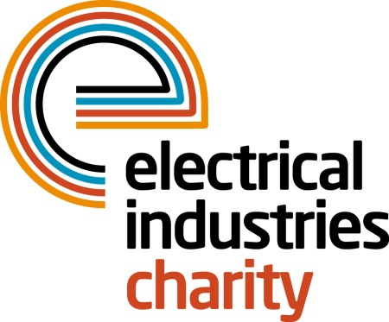
Press Release

15 March 2017

The Electrical Industries Charity extends its support network

The Electrical Industries Charity is working in partnership with the National Autistic Society to bring change in people’s lives across the electrical sector.

Currently, in the UK there are over 700,000 people that are on the autism spectrum- which is more than 1 in 100. Autism is a hidden disability that is not always noticeable to the naked eye. Only 16% of autistic adults in the UK are in full-time paid employment, and only 32% are in some kind of paid work.

According to the National Autistic Society, 70% of autistic adults in the UK say that they are not getting the help they need from social services and that with more support they would feel less isolated. Without understanding, autistic people and families are at risk of being isolated and developing mental problems.

While autism is incurable, the right level of support at the right time can make a huge difference in someone’s life. The Electrical Industries Charity is set to expand their support network by working in partnership with other charities across the industry such as the National Autistic Charity. This new partnership recognises the need of support and assistance to a large number of autistic people within the electrical industry, and therefore, is set to ensure that they receive all the support they need to live a fulfilling life.

Through the Electrical Industries Charity, the National Autistic Society is offering autistic people in the industry support services including telephone advice for someone who has not yet had the diagnosis but is in the process of seeking one, parent to parent emotional support network, ongoing autism advice and information, grants and financial advice, specialist behaviour advisor services and workplace support.

Managing Director, Tessa Ogle says: “Currently, there is a significant number of people in our industry who require assistance and help to enjoy a more fulfilling life, whether this is dealing with a medical illness or a development disability like autism.

“We have therefore, teamed up with the National Autistic Society to provide an extended support network to help people to cope with difficult situations and have more control of their lives.”

The Confidential Helpline number is: 0800 652 1618.

For further information, please contact Vicky Gray: vicky.gray@electricalcharity.org

www.electricalcharity.org

Note to editors
The Electrical Industries Charity is the national charity for the electrical, electronics and energy industries. It aims to look after people from these industries whenever they or their families need help with life’s challenges.

The charitable services are available to anyone who currently works or has worked in the very diverse and often converging industries, such as:
- Electrical contracting and facilities management
- Electrical and electronic manufacturing, wholesale, distribution and retail
- Electrical and mechanical engineering
- Lighting industry
- Generation, distribution and supply of electrical power, including nuclear and renewable energy

For further information about the Electrical Industries Charity please contact Keystone Communications:

Tracey Rushton-Thorpe Monika Gaubyte
Tel: 01733 294524 Tel: 01733 294524
Email: tracey@keystonecomms.co.uk Email: monika@keystonecomms.co.uk

