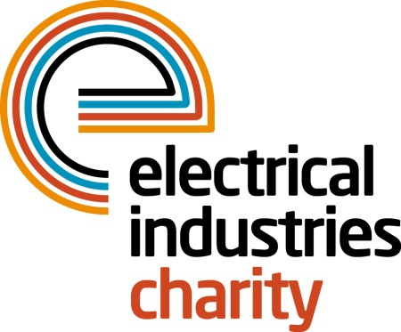
Press Release

28 February 2017

The pathway to a brighter future with the Electrical Industries Charity

The Electrical Industries Charity is creating a pathway to a better future for the Northcott family with their Pensioner Support Programme.

Alan and Linda Northcott, are in their 60’s and are caring for their son. Alan worked in electronics testing and assembly but was forced to give up work when caring for his son became challenging, and his wife Linda was unable to manage alone. Their son Nicky, aged 38, has severe learning disabilities. He was born profoundly deaf, has no speech, is epileptic, severely autistic and was recently diagnosed with a blood complaint which further complicated his care.

Alan and Linda are not in good health themselves as they suffer from high blood pressure, angina and arthritis. They are unable to have holidays alone as their son cannot be left alone with strangers. To help the elderly couple with a change of scenery and to recharge their batteries the Charity granted a respite break for the family that had facilities to accommodate Nicky with his condition. The help from the Charity has given the family a break they needed to keep going.

With its Pensioner Support Programme, the Charity assists 69% of people who are over 55 years of age, with most of this support directed at three primary care areas: financial and debt; household repairs and essential items; and mobility and disability support.

The Northcott family is one of many examples that outline the advantages of being part of the Charity’s Programme because you never know what circumstances you could be facing in later life.

Managing Director, Tessa Ogle says: “The Electrical Industries Charity is supporting our colleagues with a broad range of issues, and the Northcott family is one of many excellent examples that outline the benefits of being part of the Pensioner Support Programme which gives access to essential support at the time of need.”

For further information, please contact Vicky Gray: vicky.gray@electricalcharity.org

The Confidential Helpline number is 0800 652 1618.

www.electricalcharity.org

Note to editors
The Electrical Industries Charity is the national charity for the electrical, electronics and energy industries. It aims to look after people from these industries whenever they or their families need help with life’s challenges.

The charitable services are available to anyone who currently works or has worked in the very diverse and often converging industries, such as:
- Electrical contracting and facilities management
- Electrical and electronic manufacturing, wholesale, distribution and retail
- Electrical and mechanical engineering
- Lighting industry
- Generation, distribution and supply of electrical power, including nuclear and renewable energy

For further information about the Electrical Industries Charity please contact Keystone Communications:

Tracey Rushton-Thorpe Monika Gaubyte
Tel: 01733 294524 Tel: 01733 294524
Email: tracey@keystonecomms.co.uk Email: monika@keystonecomms.co.uk

