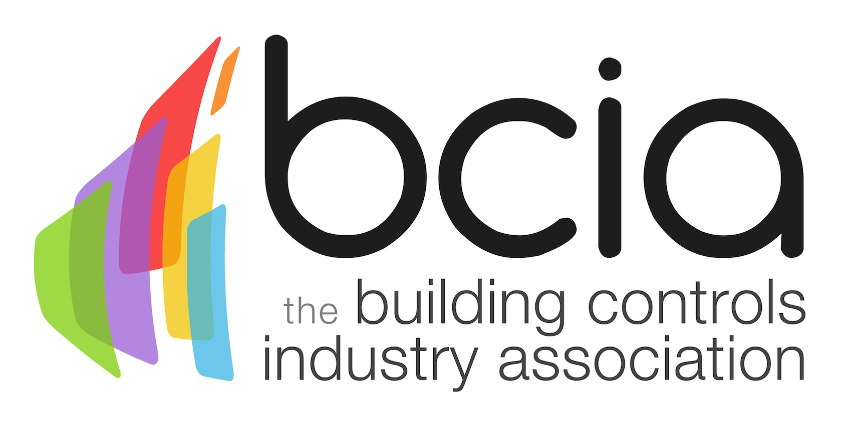

Press Release

20 March 2017

Get to grips with building controls

Electrical contractors looking to expand their knowledge of building controls can now take advantage of a suite of training courses on offer by the Building Controls Industry Association (BCIA).

Taking place at training centres in Peterborough, Edenbridge and Rotherham, the six courses are delivered by industry experts and are designed to provide a thorough knowledge and understanding of the terminology, technologies and systems used in the building controls industry.

Malcolm Anson, President of the BCIA says: “More and more electrical contractors are looking to increase their skills and knowledge of building controls and the training courses on offer by the BCIA are the ideal way to achieve this.”

The six modules (BC1-BC6) are designed for managers, electricians and engineers who are responsible for the design, installation and commissioning of building control technologies and systems for ventilation and air conditioning.

Each course is CPD accredited by CIBSE and builds on the knowledge gained in previous modules. Completion of BC1-BC3 leads to the awarding of a Technical Certificate in Building Controls with the Advanced Technical Certificate being awarded to delegates who complete BC1 – BC6.

Malcolm continues: “The BCIA has been delivering training for over 20 years but the building controls industry, like many others, is still facing a skills shortage. A continued commitment to training is the only way in which we can hope to turn this around which is why we are urging electrical contractors to take advantage of the specialist training programme as a means to learn new skills and help to drive this exciting industry forward.”

For further information about each course, its content and a full list of dates visit the BCIA website.

www.bcia.co.uk

Note to editors
The Building Controls Industry Association (BCIA) represents the UK building controls and BEMS sector. With around 75 members accounting for 70% of the UK controls market, the BCIA is an influential group that promotes better specification, application and use of controls. The BCIA also offers its own training courses and the Building Controls Professional Assessment (BCPA).

For further information about the BCIA please contact Keystone Communications:

Tracey Rushton-Thorpe
Tel: 01733 294524
Email: tracey@keystonecomms.co.uk

Leanne Elliott
Tel: 01733 294524
Email: leanne@keystonecomms.co.uk

