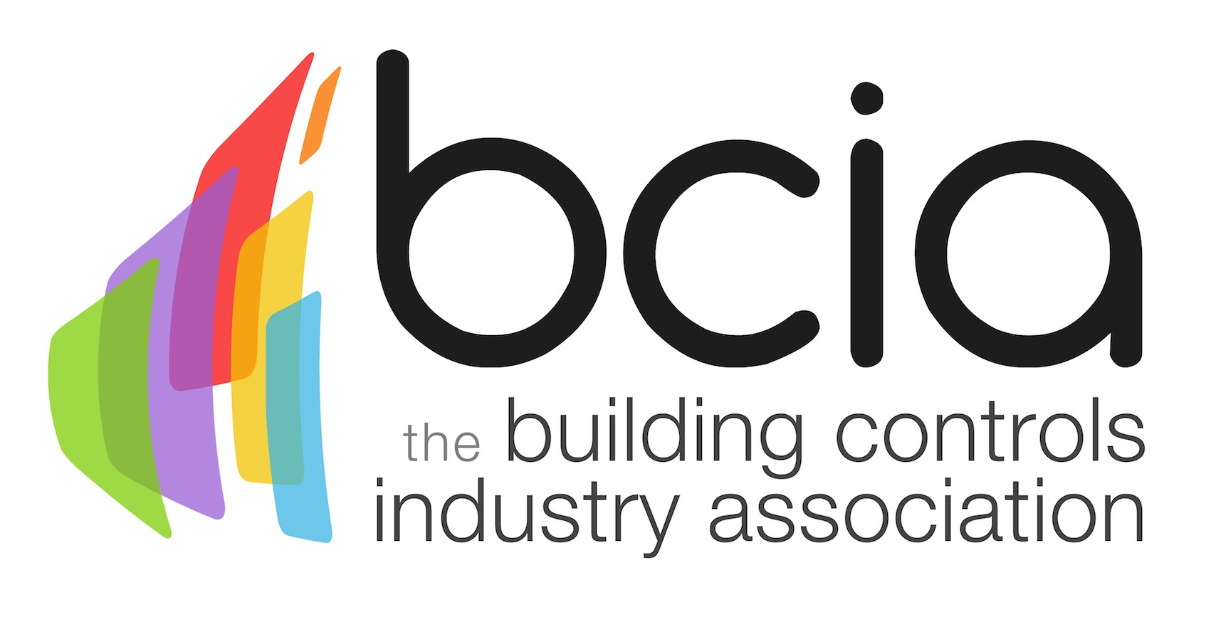

Press Release

04 April 2017

Targeting training to meet the Building Performance Challenge
The Building Controls Association (BCIA) is encouraging both the current and next generation to invest in training, to ensure that the industry continues to move in the right direction.

To conquer the building performance challenge, those employed in building services, need to be actively participating in training programmes to learn and apply new techniques. The right tools may be in place, but it’s also about having the correct skills to execute them properly. By undertaking courses and developing their expertise, the industry will see substantial benefits.

The Building Regulations – Part L (2013) provides a mandatory methodology which covers new build and refurbishment projects. The legislation states fixed building services need to be energy efficient and have effective controls.

Alarmingly, at the 2016 Building Services Summit, it was revealed that a large majority of builders do not understand building controls. It is imperative that they can install and operate controls correctly; therefore, meeting the legislation and satisfying the client’s requirements.

It is the responsibility of builders and engineers, to implement controls which contribute to reducing the costs of the building, particularly in the current economic climate. This is where training is so influential and can bear a significant impact on the financial interests of the customer over a long period of time.

If a building is not performing as it was originally intended, the outcome will be higher operational and maintenance costs. Engineers need to engage with their clients to make sure they understand the life-long performance gains that can be obtained from building controls. It is crucial that the customer is aware of the significant savings they could make, along with making a potential return on their investment.

Malcolm Anson, President of the BCIA says: “Building controls are integral to energy savings and long term performance. However, it is apparent that there is a lack of understanding on the true value of controls and the advantages they bring.

“Right now, we are suffering from a skills-shortage and a shortfall of younger people employed in the sector. Collectively, we must adopt a proactive approach and address this, to build a strong foundation for the future of the industry. We need to reach out to the next crop of budding engineers and demonstrate that the engineering career path is an exciting and worthwhile route to embark on.

“Technology continues to evolve at a fast pace and we as an industry must keep up to date with the latest advancements available. It is key we have knowledgeable and trained professionals.
“We must also remember to share our knowledge with linked sectors and with colleagues. By upskilling and learning from one another, we can make sure the industry benefits, with sustainable and energy-efficient buildings, that bring a return on the client’s investment.”

www.bcia.co.uk

Note to editors
The Building Controls Industry Association (BCIA) represents the UK building controls and BEMS sector. With around 75 members accounting for 70% of the UK controls market, the BCIA is an influential group that promotes better specification, application and use of controls. The BCIA also offers its own training courses and the Building Controls Professional Assessment (BCPA).

For further information about the BCIA please contact Keystone Communications:

Tracey Rushton-Thorpe
Tel: 01733 294524
Email: tracey@keystonecomms.co.uk

Leandra Graves
Tel: 01733 294524
Email: leandra@keystonecomms.co.uk

