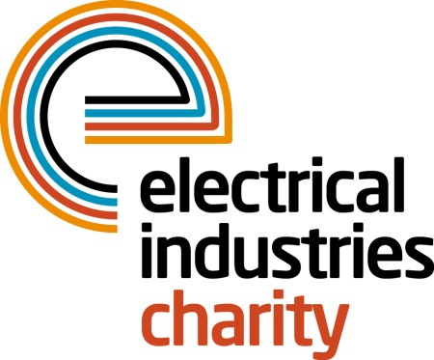
Press Release

03 April 2017

Are you ready to take on a Challenge for a Cause in 2018?

Are you an adventurous type who is looking for the next exciting challenge which will help to reshape the future of those in need? The Electrical Industries Charity is looking for brave individuals to join their second Challenge for a Cause campaign to raise funds for the Dickinson family.

Caz Dickinson, a mother, grandmother and a loving wife spent 15 years working for a large electrical wholesaler until her life changed in the blink of an eye. On the 4 January 2009, Caz collapsed in her home, hit her head on the bathroom floor and was rushed to hospital where she was diagnosed with a Grade 4 brain haemorrhage. Since her collapse, she has faced numerous major operations and has been left with severe, irreversible brain damage.

Over the years, Caz’s husband Mick has helped her through her struggles and kept her positive while supporting their three daughters. Throughout this time, the family struggled to get financial aid, and after being made redundant from his job, Mick was left without any income to cover the mortgage, hospital visits and other expenses. This resulted in them losing their family home in October 2013.

Despite the challenging situation, Mick found another job and a rented property which would accommodate his wife upon her return from the hospital. In November 2015, he was given the option to take voluntary redundancy, which gave him an opportunity to bring Caz home and become her full-time carer.

To help the Dickinson family with their financial struggles and to allow the family to focus on caring for Caz the Charity has launched their second Challenge for a Cause campaign - Arctic Adventure 2018. This incredible challenge is aiming to raise £250,000 for the Dickinson family which will allow them to secure a lasting family home and will help with Caz’s development and care.

Do you have what it takes to complete the Arctic Challenge? Join the Charity’s adventure of a lifetime and experience cross-country skiing, snowshoeing and husky-sledding while making a real difference to the Dickinson’s family life. The Arctic Adventure is taking place between 8-12 March 2018 in Finland, Kuusamo.

Managing Director, Tessa Ogle says: “After the great success of our very first Challenge for a Cause - Mount Kilimanjaro 2017 - we are proud to announce our new challenge - the Artic Adventure. Join us on this incredible journey and help us to create a brighter future for the Dickinson family.”

For further details, or to participate visit,

www.electricalcharity.org

Note to editors
The Electrical Industries Charity is the national charity for the electrical, electronics and energy industries. It aims to look after people from these industries whenever they or their families need help with life’s challenges.

The charitable services are available to anyone who currently works or has worked in the very diverse and often converging industries, such as:
- Electrical contracting and facilities management
- Electrical and electronic manufacturing, wholesale, distribution and retail
- Electrical and mechanical engineering
- Lighting industry
- Generation, distribution and supply of electrical power, including nuclear and renewable energy

For further information about the Electrical Industries Charity please contact Keystone Communications:

Tracey Rushton-Thorpe Monika Gaubyte
Tel: 01733 294524 Tel: 01733 294524
Email: tracey@keystonecomms.co.uk Email: monika@keystonecomms.co.uk

