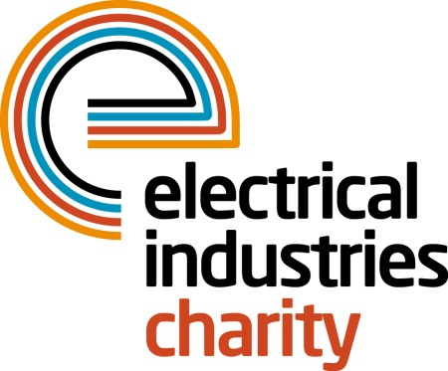
Press Release

30 March 2017

Take on a life-changing challenge in 2017

The Electrical Industries Charity is calling on the electrical and energy industries to take on a life-changing challenge for people in your industry by participating in one or all of the Charity’s sporting events this summer.

The Charity has a wide range of events to choose from which will get you fit, push you beyond your limits and leave you with long-lasting memories for many years to come.

You can challenge your physical strength, mental grit and overcome your biggest fears while completing the toughest obstacle course in the UK – the Tough Mudder 2017. At the Tough Mudder, you will have a chance to step outside of your comfort zone and push yourself beyond your limits as you overcome over 20 obstacles. This world’s greatest mud run is taking place at various UK locations between 13 May 2017- 24 September 2017. For further information, please visit the Charity’s official website.

Or why not get involved with one of the Charity’s leading sporting events – Volleyball 2017 and compete against your industry rivals alongside members of team GB. Sign up your team of six players for only £800 today and experience volleyball in a fun atmosphere while raising vital funds for your colleagues. EIC Volleyball 2017 is taking place on Thursday 29 June 2017 at Richmond Volleyball Club, Teddington Beach Courts, Richmond.

Managing Director, Tessa Ogle says: “The Charity has an event for anyone who wants step out of their comfort zone, get fit, and have fun this summer. Together with family and friends, you can help the Charity to transform the lives of colleagues in need. So, join one or all of our sporting events and have a summer to remember.”

For further information or to book your place, please contact Charlotte Laurent: charlotte.laurent@electricalcharity.org
www.electricalcharity.org

Note to editors
The Electrical Industries Charity is the national charity for the electrical, electronics and energy industries. It aims to look after people from these industries whenever they or their families need help with life’s challenges.

The charitable services are available to anyone who currently works or has worked in the very diverse and often converging industries, such as:
- Electrical contracting and facilities management
- Electrical and electronic manufacturing, wholesale, distribution and retail
- Electrical and mechanical engineering
- Lighting industry
- Generation, distribution and supply of electrical power, including nuclear and renewable energy

For further information about the Electrical Industries Charity please contact Keystone Communications:

Tracey Rushton-Thorpe Monika Gaubyte
Tel: 01733 294524 Tel: 01733 294524
Email: tracey@keystonecomms.co.uk Email: monika@keystonecomms.co.uk

