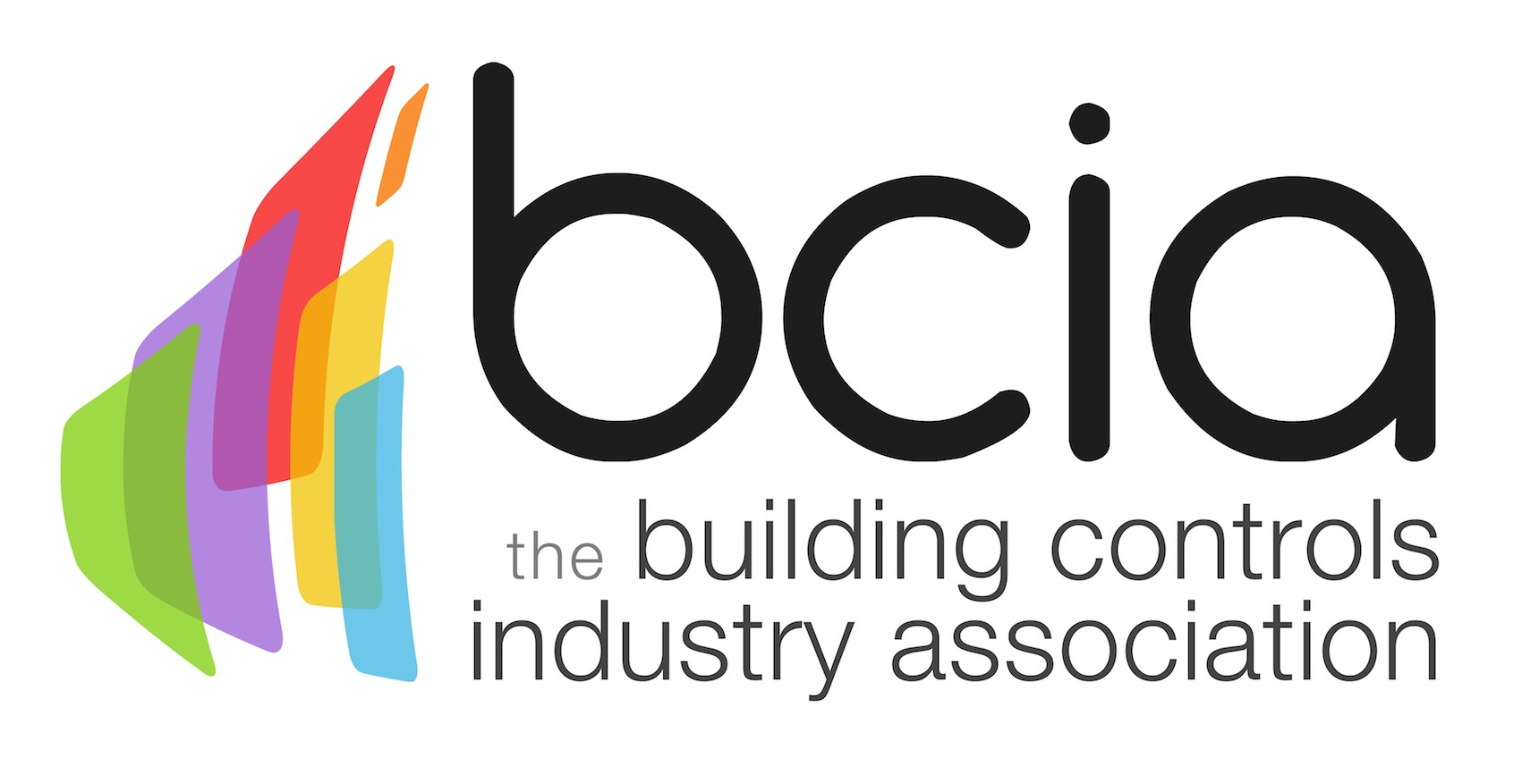

Press Release

21 April 2017

Learn about HVAC and building technology with the BCIA

Building services professionals looking to develop their knowledge of HVAC and building technology are urged to enrol on the first of a suite of six courses offered by the Building Controls Industry Association (BCIA).

BC1 - Fundamentals of HVAC and Building Technology, is designed for managers, designers and installation engineers and will equip individuals with an understanding of the requirements of buildings and building services installation, as well as an understanding of HVAC systems and their main components.

Now is the time to invest in training, particularly with the upcoming industry standard, Minimum Energy Performance Standard (MEPS) due to be introduced in April 2018. The standard states that it will be unlawful to let any building that does not achieve an energy performance rating of E or above. Building controls are an effective solution to ensure buildings perform to a high standard, but only if building services professionals have the knowledge to install the most effective systems.

Malcolm Anson, President of the BCIA says: “Building controls are the way forward to improve the energy efficiency and performance of buildings. The BCIA believes that through its training programme, individuals will gain the knowledge and understanding they need to be able to tackle the ongoing challenges arising in the built environment.

“BC1 is the ideal starting point as the knowledge learnt here provides a foundation which will be built upon over the duration of the training programme.”

On successful completion of BC1, participants will be awarded with a CPD certificate accredited by CIBSE, which is the first step towards gaining a Technical and Advanced Technical Certificate in Building Controls.

For further information on all BCIA courses, their content and to book your place visit the website.
www.bcia.co.uk

Note to editors
The Building Controls Industry Association (BCIA) represents the UK building controls and BEMS sector. With around 75 members accounting for 70% of the UK controls market, the BCIA is an influential group that promotes better specification, application and use of controls. The BCIA also offers its own training courses and the Building Controls Professional Assessment (BCPA).

For further information about the BCIA please contact Keystone Communications:

Tracey Rushton-Thorpe
Tel: 01733 294524
Email: tracey@keystonecomms.co.uk

Leanne Elliott
Tel: 01733 294524
Email: leanne@keystonecomms.co.uk

