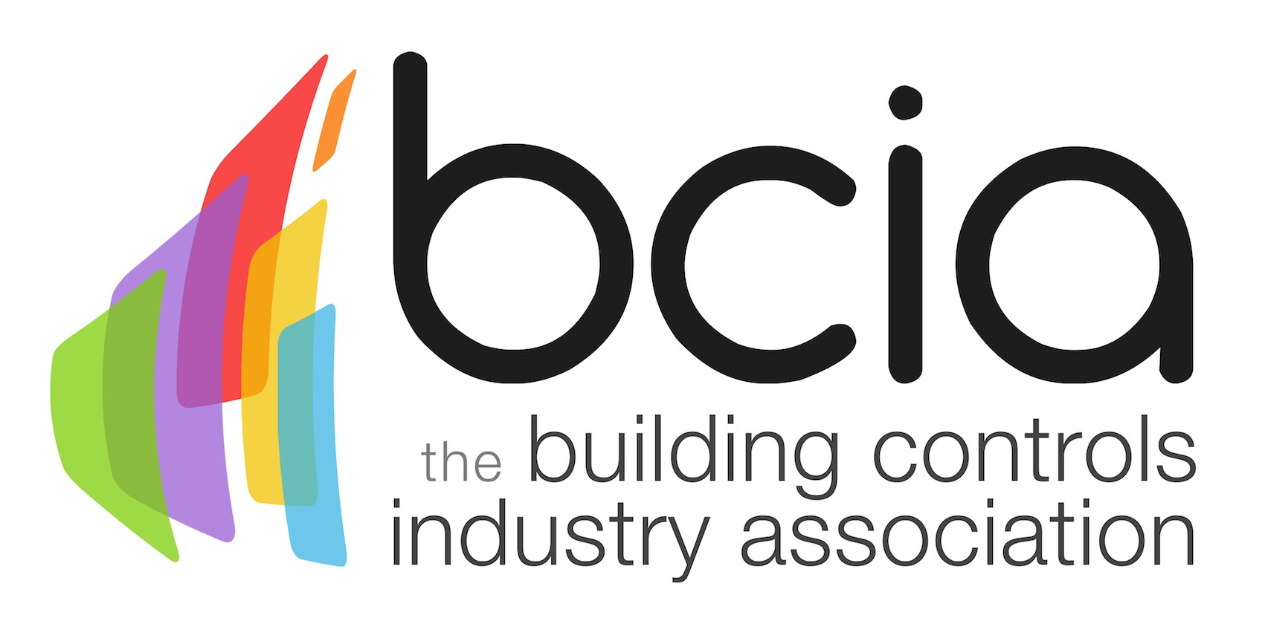
Press Release

30 March 2017

BCIA urges building services professionals to invest in training

The Building Controls Industry Association (BCIA) is encouraging building services professionals to improve their knowledge of building controls by enrolling on its suite of training courses.

The six modules are designed for facilities managers, installation engineers and technicians who are responsible for the design, installation and commissioning of building control technologies and systems for ventilation and air conditioning.

The courses are suitable for individuals starting out in their career, as well as those wanting to know how to get the most out of controls and experienced engineers who need to keep up to date with the latest technologies.

Taking place at training centres in Peterborough, Edenbridge and Rotherham, the six courses are delivered by industry experts and are designed to provide a thorough knowledge and understanding of the terminology, technologies and systems used in the building controls industry.
Malcolm Anson, President of the BCIA says: “With new technologies being introduced all the time, it is important to keep up to date and not get left behind. The BCIA training courses offer the ideal way to stay ahead of the game.”

Each course builds on the knowledge gained in previous modules and is CPD accredited by CIBSE. On completion of BC1 – BC3 delegates will be awarded with a Technical Certificate in Building Controls and on completion of BC1 – BC6 an Advanced Technical Certificate will be awarded.

Malcolm adds: “The BCIA has been offering training for over 20 years now. The training programme is highly regarded throughout the construction industry, with more and more specifiers asking for individuals to prove their competence.

“We are urging building services professionals to take advantage of the BCIA training programme to not only increase their knowledge but also to raise the profile of the building controls industry.”

For further information on full course content and the available dates visit the BCIA website.
www.bcia.co.uk

Note to editors
The Building Controls Industry Association (BCIA) represents the UK building controls and BEMS sector. With around 75 members accounting for 70% of the UK controls market, the BCIA is an influential group that promotes better specification, application and use of controls. The BCIA also offers its own training courses and the Building Controls Professional Assessment (BCPA).

For further information about the BCIA please contact Keystone Communications:

Tracey Rushton-Thorpe
Tel: 01733 294524
Email: tracey@keystonecomms.co.uk

Leanne Elliott
Tel: 01733 294524
Email: leanne@keystonecomms.co.uk

