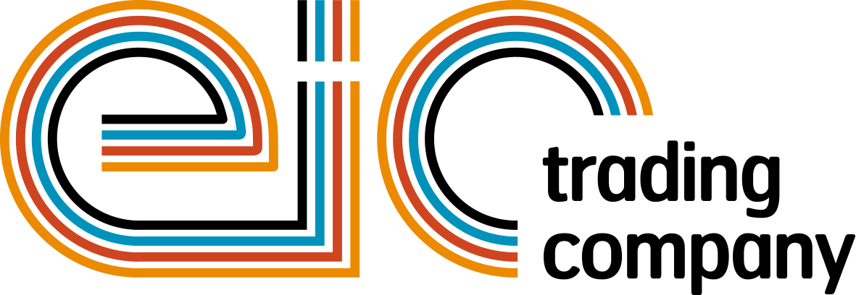

Press Release

18 April 2017

Put your company in the spotlight at powerBall 2017

Are you ready for another unforgettable night? This year powerBall 2017 is set for a remarkable disco explosion with City Electrical Factors (CEF) as the headline sponsor for the second year running.

This year’s dance extravaganza will take you on a journey through the days of 70’s disco and will get your feet moving all night long to the best entertainment from the new band Madhen, and DJ Laura. Guests on the night will also experience the outstanding performance of 12 talented young dancers who will recreate the 70’s phenomenon of Saturday Night Fever choreographed by Nikki Trow.

powerBall 2017 is also offering an excellent opportunity to all electrical, electronics and energy sector professionals to showcase their business while raising the roof for the Dickinson family. Raise the roof campaign is offering you the opportunity to be part of transforming the future for the Dickinson family by sponsoring one brick at a time.

You will have your name/company name engraved on each brick that you sponsor, when completing your booking for powerBall 2017. A personalised brick allows donors to literally put their names on this very special project and this means that each engraved brick will serve as long lasting tributes for the Dickinson family.
Each sponsored brick will go towards building a lasting family home for the Dickinson family and will help with Caz’s development and care. Read the full story on the Electrical Industries Charity’s official website: http://www.electricalcharity.org/index.php/fundraising/challenge-for-a-cause/2017-2018

Or why not become a sponsor for one of the jiving sponsorship packages which include Disco Dance Floor Sponsor, Boogie Cam, Higher or Lower and Casino Sponsorship. There is an opportunity for everyone to get their company in the spotlight while enjoying the Friday Night Fever themed event.

Charlie Beddows, Managing Director at CEF, says: “We are excited to be the headline sponsors for one of the biggest and most phenomenal events in the electrical industry and we are looking forward to seeing everyone at powerBall 2017.”

Managing Director, Tessa Ogle says: “We are delighted to have CEF as our headline sponsor for the second year in a row. The continuing support of our sponsors ensures the ongoing success of powerBall. We are looking forward to the industry coming together for another memorable night of the year.”

Don’t miss the opportunity to put your company in the spotlight at the must-attend event in the electrical industry calendar. powerBall 2017 is taking place on Friday 10 November at Grosvenor House Hotel, London.

For more information on sponsorships or to book your place, please contact Ali Welsh: events@eictradingco.org

www.eictradingco.org

Note to editors
powerBall 2017 is being run by The Electrical Industries Trading Company Limited which is a wholly owned subsidiary of the Electrical Industries Charity.

The Electrical Industries Charity is the national charity for the electrical, electronics and energy industries. It aims to look after people from these industries whenever they or their families need help with life’s challenges.

The charitable services are available to anyone who currently works or has worked in the very diverse and often converging industries, such as:
- Electrical contracting and facilities management
- Electrical and electronic manufacturing, wholesale, distribution and retail
- Electrical and mechanical engineering
- Lighting industry
- Generation, distribution and supply of electrical power, including nuclear and renewable energy

www.electricalcharity.org

For further information about powerBall 2017 please contact Keystone Communications:

Monika Gaubyte
Tel: 01733 294524
Email: monika@keystonecomms.co.uk

Tracey Rushton-Thorpe
Tel: 01733 294524
Email: tracey@keystonecomms.co.uk

