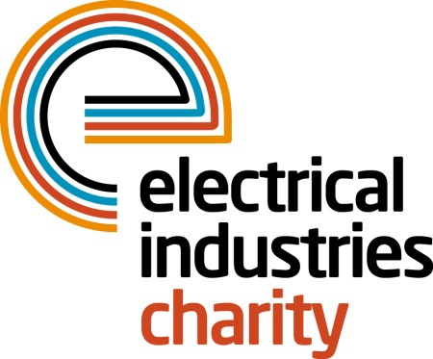
Press Release

22 May 2017

Around the world in 80 days with the Electrical Industries Charity

The Electrical Industries Charity invites you to get active this summer by taking on a walking challenge of 80 days around the world while raising vital funds for the Dickinson family.

The Charity’s journey around the world is part of its new Challenge for a Cause campaign, which aims to raise £250,000 to transform the Dickinson family’s lives by giving them a long-lasting family home and help Caz Dickinson, a loving wife and a mother of three, with her development. Read the full story on the Electrical Industries Charity’s official website: http://www.electricalcharity.org/index.php/fundraising/challenge-for-a-cause/2017-2018

One step at a time virtual travel around the world is open to anyone looking to find fun in fitness and get in shape this summer. ‘The Around the world in 80 days’ campaign is also the perfect way to get your family and friends active this summer and reap the benefits of a healthier lifestyle. It is easy and a great way to get kids active this summer too.

You can choose your personal goal for the distance that you would like to achieve, which can be travelled in any way you like, including jogging, walking, skipping, swimming, hopping, rowing or cycling, just remember to have fun. All you need to do is log your journey on the Charity’s world walking app which will then be added to the Charity’s 80 day challenge.

The Charity is aiming to raise at least £1 for each mile achieved on its around the world in 80 days journey. You can fundraise for your own around the world miles any way you like, through sponsorship, bucket collections, workplace donations, it is up to you.

The Electrical Industries Charity’s 80 day challenge will start on Monday 26 June with the aim of reaching the goal of 34,113 miles by Wednesday 13 September 2017.

Managing Director, Tessa Ogle says: “We are delighted to announce our Around the World in 80 days campaign which will bring family, friends and colleagues together to enjoy fitness in a fun way while at the same time transforming the lives of the Dickinson family.”

Don’t miss your chance to leave a footprint in someone’s life while virtually travelling around the world. To sign up as a member of the EIC Walking Group and join our challenge, download the full instructions from the Charity’s official website http://www.electricalcharity.org/index.php/fundraising/around-the-world-in-80-days, it only takes few minutes to join. Or if you would like to go around the world alone, please contact: fundraising@electricalcharity.org

www.electricalcharity.org

Note to editors
The Electrical Industries Charity is the national charity for the electrical, electronics and energy industries. It aims to look after people from these industries whenever they or their families need help with life’s challenges.

The charitable services are available to anyone who currently works or has worked in the very diverse and often converging industries, such as:
- Electrical contracting and facilities management
- Electrical and electronic manufacturing, wholesale, distribution and retail
- Electrical and mechanical engineering
- Lighting industry
- Generation, distribution and supply of electrical power, including nuclear and renewable energy

For further information about the Electrical Industries Charity please contact Keystone Communications:

Tracey Rushton-Thorpe Monika Gaubyte
Tel: 01733 294524 Tel: 01733 294524
Email: tracey@keystonecomms.co.uk Email: monika@keystonecomms.co.uk

