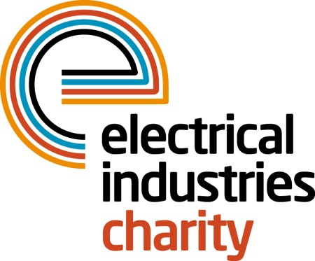
Press Release

03 May 2017

Essential support for young talent

The Electrical Industries Charity recognises the importance of the essential support network for young talent in the electrical industry and launched the Apprentice Support Programme to help apprentices to create a career they deserve.

Apprenticeships offer a unique opportunity for a young person in the electrical industry to earn and learn while gaining invaluable training and life skills. Although there are a lot of young people in the electrical sector who are trying to build their career, for some, this is not an option due to unforeseen circumstances in their lives.

The Apprentice Support Programme provides young adults with the right level of support with many issues including financial, emotional, health and family factors that may be in the way of pursuing a dream of starting a new career. The Charity’s programme provides services including career development and transition assistance, debt advice, financial assistance, legal advice, apprentice scholarships and bursary scheme, financial grants and assistance, and support for carers.

The programme aims to make it easier for young people to reach their potential and has already helped many do just this. In a recent example, twenty-year-old Billy was diagnosed with bone cancer in the final year of his apprenticeship, which was extremely aggressive and required a life-saving amputation. To regain his independence and complete his apprenticeship, Billy needed a prosthetic limb. His family, together with the support of the Electrical Industries Charity’s Apprentice Support Programme and the local community, were able to raise the money for the limb and have enabled Billy to continue his career.

Billy’s story is one of many examples that outline the difficulties that the future stars of our industry are facing in order to reach their goals, and defines the benefits of being part of the Apprentice Support Programme.

Managing Director, Tessa Ogle says: “Every so often, no matter how young or old you are we all need a support network to help us reach a goal. We have launched the Apprentice Support Programme to ensure young talent in our industry has this support to build the career they deserve.”

For more information, please contact Vicky Gray: vicky.gray@electricalcharity.org

www.electricalcharity.org

Note to editors
The Electrical Industries Charity is the national charity for the electrical, electronics and energy industries. It aims to look after people from these industries whenever they or their families need help with life’s challenges.

The charitable services are available to anyone who currently works or has worked in the very diverse and often converging industries, such as:
- Electrical contracting and facilities management
- Electrical and electronic manufacturing, wholesale, distribution and retail
- Electrical and mechanical engineering
- Lighting industry
- Generation, distribution and supply of electrical power, including nuclear and renewable energy

For further information about the Electrical Industries Charity please contact Keystone Communications:

Tracey Rushton-Thorpe Monika Gaubyte
Tel: 01733 294524 Tel: 01733 294524
Email: tracey@keystonecomms.co.uk Email: monika@keystonecomms.co.uk

