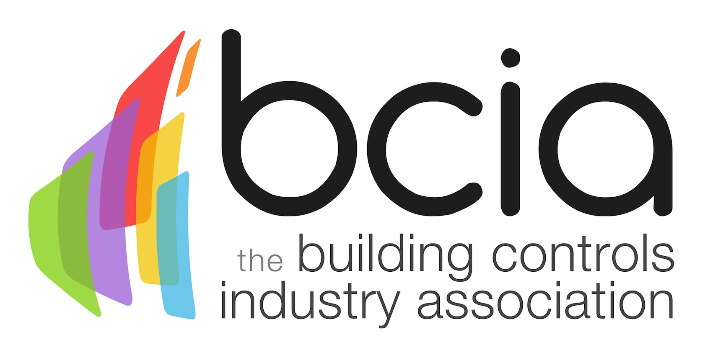

Press Release

21 May 2017

Invest in training for future success

The Building Controls Industry Association (BCIA) is inviting building services professionals to expand on their building controls knowledge with the second in a suite of six courses to be offered as part of the BCIA training programme.

BC2 - Measuring and Control Technology is designed for engineers and installers and will equip participants with an understanding of the basic terms of control technology. The course covers measuring and control technology in depth, as well as the correct use and application of equipment used for measuring HVAC systems.

The building controls industry has a significant role to play when it comes to improving energy efficiency in the built environment. The industry needs skilled and knowledgeable individuals, to offer the most effective control solutions and achieve lifelong building performance.

With ambitious government targets to meet, such as an 80% reduction in greenhouse gases in the UK by 2050, invaluable tools such as BS EN 15232 help the industry to show the true value of building controls. Now is the time to put training at the top of the business agenda and equip building services professionals with specialist skills to do this.
Malcolm Anson, President of the BCIA says: “Building controls are key to improving energy efficiency. Investing in training will ensure individuals are equipped with the knowledge and skills to install effective control solutions to create energy efficient buildings.”

On successful completion of BC2, participants will be awarded with a CPD certificate accredited by CIBSE. This together with completion of BC1 and BC3, will lead to an industry wide recognised Technical Certificate in Building Controls.

The BCIA training programme takes place at training centres in Peterborough, Edenbridge and Rotherham. For further information on all BCIA courses and to book your place, visit the website.

www.bcia.co.uk

Note to editors
The Building Controls Industry Association (BCIA) represents the UK building controls and BEMS sector. With around 75 members accounting for 70% of the UK controls market, the BCIA is an influential group that promotes better specification, application and use of controls. The BCIA also offers its own training courses and the Building Controls Professional Assessment (BCPA).

For further information about the BCIA please contact Keystone Communications:

Tracey Rushton-Thorpe
Tel: 01733 294524
Email: tracey@keystonecomms.co.uk
Leanne Elliott
Tel: 01733 294524
Email: leanne@keystonecomms.co.uk

