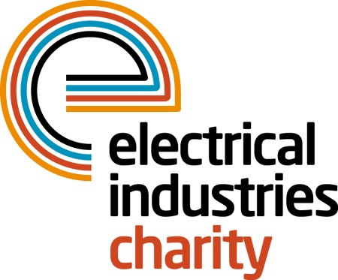
Press Release

16 May 2017

BlueSky Pensions supports new Challenge for a Cause

The Electrical Industries Charity is working in partnership with BlueSky Pensions to increase awareness of the new Challenge for a Cause campaign which aims to raise £250,000 to transform the lives of the Dickinson family.

BlueSky will be promoting the Electrical Industries Charity’s new Challenge for a Cause ‘Raise the Roof’ campaign at their Annual Summer Party 2017.

The Electrical Industries Charity’s ‘Raise the Roof’ campaign was set up to help the Dickinson family to look forward to the future and help a mother of three, Caz Dickinson with her development. By sponsoring one brick at a time, you will have a unique opportunity to have your name/company name engraved on each brick that you sponsor.

A personalised brick allows you to put your name on this very special project and serve as long lasting tributes for the Dickinson family while helping them to have a long-lasting family home. Read the full story on the Electrical Industries Charity’s official website: http://www.electricalcharity.org/index.php/fundraising/challenge-for-a-cause/2017-2018

BlueSky’s Summer Party is taking place at the dazzling Sky Bar in London on Thursday 15 June 2017 at the Grange, St Paul’s in London.

Guests on the night will have a chance to enjoy one of the most iconic views in London while learning about BlueSky’s innovative product offerings. The event promises to bring the best entertainment on the night with the award-winning comedian Nathan Caton and the soulful singer Lorena Dale.

Managing Director, Tessa Ogle says: “We are excited to be working in partnership with BlueSky Pensions who will be helping us on this new challenge to raise essential funds and transform the lives of the Dickinson family.”

Alice Moloney, Head of Marketing at BlueSky says: “We are delighted to be working together with the Electrical Industries Charity and bringing awareness of such an extraordinary cause. We believe that the ‘Raise the Roof’ campaign is an incredible way to get everyone involved to help the Dickinson family to have a life they deserve and most importantly help Caz with her development.”

For further information, please contact Vicky Gray: vicky.gray@electricalcharity.org

www.electricalcharity.org

Note to editors
The Electrical Industries Charity is the national charity for the electrical, electronics and energy industries. It aims to look after people from these industries whenever they or their families need help with life’s challenges.

The charitable services are available to anyone who currently works or has worked in the very diverse and often converging industries, such as:
- Electrical contracting and facilities management
- Electrical and electronic manufacturing, wholesale, distribution and retail
- Electrical and mechanical engineering
- Lighting industry
- Generation, distribution and supply of electrical power, including nuclear and renewable energy

For further information about the Electrical Industries Charity please contact Keystone Communications:

Tracey Rushton-Thorpe Monika Gaubyte
Tel: 01733 294524 Tel: 01733 294524
Email: tracey@keystonecomms.co.uk Email: monika@keystonecomms.co.uk

