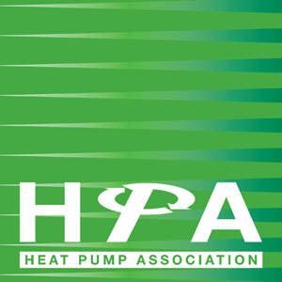

Press Release

10th April 2017

HPA acknowledges RHI reform delay

Although the 2017 reform of the Renewable Heat Incentive (RHI) Regulations were placed before parliament on 14th March 2017, it became apparent by Friday 31st March that due to drafting issues with the Non-Domestic Regulations there would be a delay before parliament could consider both in detail.

As a result, the date that the regulations go live is now more likely to fall towards the middle or end of June 2017 rather than the middle of May.

The Heat Pump Association (HPA) acknowledges that the delay is far from ideal but believes it could prove beneficial for those hoping to complete projects with high heat demands.

Heat demand limits are being introduced in the reform package in an attempt to limit the possibility of high rates of return for large projects with economies of scale.

HPA President, Mike Nankivell, comments: “This delay offers some breathing space to complete larger domestic installations prior to the introduction of heat demand limits whilst still benefiting from the new tariff rates.

“The delay to the potential tariff guarantees for non-domestic ground source heat pump projects over 100kW is unfortunate but hopefully this will not significantly impact on the industry.”

The HPA has ascertained that the actual policy as previously outlined will not change, merely the wording of the law. The HPA continues to highlight the positive impact of the RHI and advises the Department for Business, Energy & Industrial Strategy (BEIS) on its benefits to industry.

Ofgem has now published three guidance documents around the spring/summer 2017 RHI regulations changes and these can be accessed through the following links:

Webpage – Do I need metering?
Factsheet – Do I need metering?
Factsheet – Important Changes to the Scheme

Note to Editors

The Heat Pump Association (HPA) is the UK’s leading authority on the use and benefits of heat pump technology and includes many of the country’s leading manufacturers of heat pumps, components and associated equipment.

The Association influences legislation and other matters that affect the interests of either the industry in general, or its members in particular. In addition, the HPA coordinates technical and market research into areas of mutual interest, identified by members with the aim of improving market opportunities for members, at home and abroad.

The HPA is part of FETA – the Federation of Environmental Trade Associations – a UK body representing the interests of over 400 manufacturers, suppliers, installers and contractors within heating, ventilating, building controls, refrigeration and air conditioning.

www.heatpumps.org.uk

For further information, please contact Keystone Communications:

Michael Crane
Tel: 01733 294524
Email: michael@keystonecomms.co.uk

Tracey Rushton-Thorpe
Tel: 01733 294524
Email: tracey@keystonecomms.co.uk

