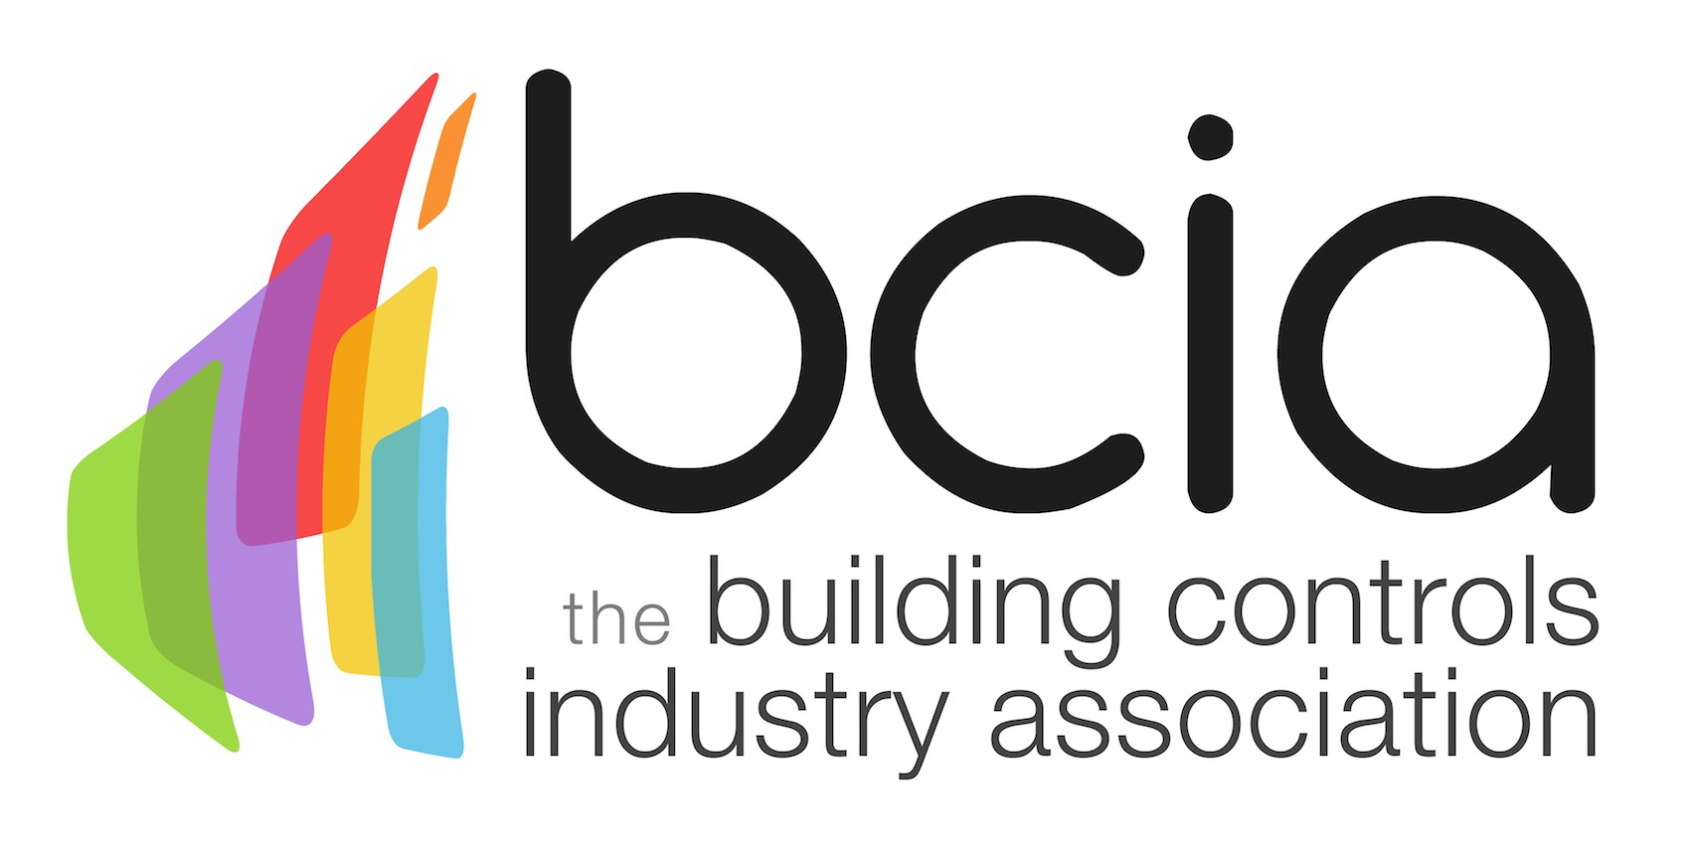

Press Release

7 June 2017

Training will transform building controls industry

The Building Controls Association (BCIA) believes the key to a sustainable future in the building controls industry is to invest in young people and find skilled role models for the next generation.

The current skills shortage faced by the industry has been well documented. A recent survey conducted by UK Construction Week discovered that 67% of respondents identified a lack of knowledge as a serious issue in preventing buildings being run more efficiently, highlighting that more needs to be done in terms of education and training.

To tackle the building performance challenge head-on, building controls engineers must be fully trained to optimise buildings and correctly ascertain which controls will be of most benefit to deliver cost savings and enhance overall comfort.

Technical qualifications called T-levels will be introduced next year for 16-19 year olds following a sizeable investment from the government. Construction and engineering are set to be two of the key areas which will benefit from this.
George Belfield, is an ideal illustration of what a young person can achieve with the right training and guidance. George recently won the coveted Young Engineer of the Year accolade at the prestigious BCIA Awards 2017 and works for InTandem Systems.

Inspired by his older brother who was an electrician, George embarked on an intense training programme and has since gained valuable experience by working on various international projects.
George’s next step is to progress up the ranks and become a building controls engineer as he continues his development in his chosen field. George’s journey has been transformed thanks to obtaining the necessary skills and expertise through ongoing training.

Developing the industry’s talented engineers and retaining them is pivotal. Like George, the industry needs more role models and inspirational figures to encourage and motivate young people to opt for a career in this sector.

Malcolm Anson, President of the BCIA says:” We can all play a significant role in helping shape the future of the building controls industry. Let’s unearth the next crop of controls engineers and demonstrate our passion for the sector. Finding suitable role models will be vital in capturing the imagination of young people who wish to make a career in building controls. We must inspire and educate the next generation to ensure a sustainable future across the whole industry.”

www.bcia.co.uk
Note to editors
The Building Controls Industry Association (BCIA) represents the UK building controls and BEMS sector. With around 75 members accounting for 70% of the UK controls market, the BCIA is an influential group that promotes better specification, application and use of controls. The BCIA also offers its own training courses and the Building Controls Professional Assessment (BCPA).

For further information about the BCIA please contact Keystone Communications:

Tracey Rushton-Thorpe
Tel: 01733 294524
Email: tracey@keystonecomms.co.uk

Leandra Graves
Tel: 01733 294524
Email: leandra@keystonecoms.co.uk

