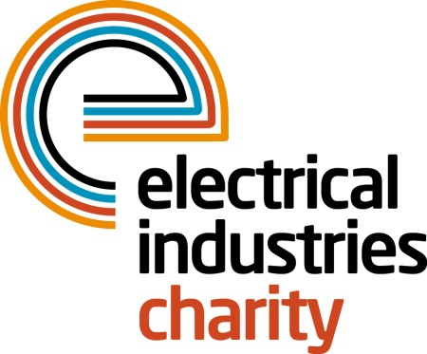
Press Release

31 May 2017

CEF raising the roof for the Electrical Industries Charity

City Electrical Factors (CEF) is set to Raise the Roof for the Dickinson family as part of the Electrical Industries Charity’s Challenge for a Cause campaign at CEF LIVE 2017.

Back by popular demand, CEF LIVE returns to Birmingham’s NEC Arena on the 8th - 9th June, 2017. Hosted by CEF, the UK’s expert supplier of electrical products and services, this year’s event runs across two days and will feature industry leading brands, exclusive on-the-day offers and vital information about upcoming industry changes.

During the event, CEF will be raising funds for the Electrical Industries Charity to help the Charity to provide essential support for people in the electrical industry who are going through difficult circumstances in their lives and are in need of a helping hand.

On Saturday 10th June 2017, CEF will be raising funds for the Charity’s Raise the Roof campaign during their Gala dinner with their F1 Challenge and Gala dinner raffle. CEF will also be donating every penny that they have raised from the sale of carrier bags across all of the CEF branches in the past year which will go towards raising a roof for the Dickinson family.
The Electrical Industries Charity’s ‘Raise the Roof’ campaign was set up to help the Dickinson family to look forward to the future and help a mother of three, Caz Dickinson with her development. By sponsoring one brick at a time, fundraisers will have a unique opportunity to have their name/company name engraved on each brick that they sponsor.

Charlie Beddows, Managing Director at CEF, says: “CEF LIVE is one of the key events in the electrical industry and this year will be bigger and better than ever, particularly as visitors will be able to gain a first insight into how the new edition of BS 7671 could affect the way they work ahead of The IET Wiring Regulations 18th Edition later this year.

“We are delighted to be supporting the Electrical Industries Charity at our CEF LIVE and Conference and to be raising money for the Dickinson family, who need support to help them to look forward to the future and help Caz with her development.”

For further information, please contact Vicky Gray: vicky.gray@electricalcharity.org

www.electricalcharity.org

Note to editors
The Electrical Industries Charity is the national charity for the electrical, electronics and energy industries. It aims to look after people from these industries whenever they or their families need help with life’s challenges.

The charitable services are available to anyone who currently works or has worked in the very diverse and often converging industries, such as:
- Electrical contracting and facilities management
- Electrical and electronic manufacturing, wholesale, distribution and retail
- Electrical and mechanical engineering
- Lighting industry
- Generation, distribution and supply of electrical power, including nuclear and renewable energy

For further information about the Electrical Industries Charity please contact Keystone Communications:

Tracey Rushton-Thorpe Monika Gaubyte
Tel: 01733 294524 Tel: 01733 294524
Email: tracey@keystonecomms.co.uk Email: monika@keystonecomms.co.uk

