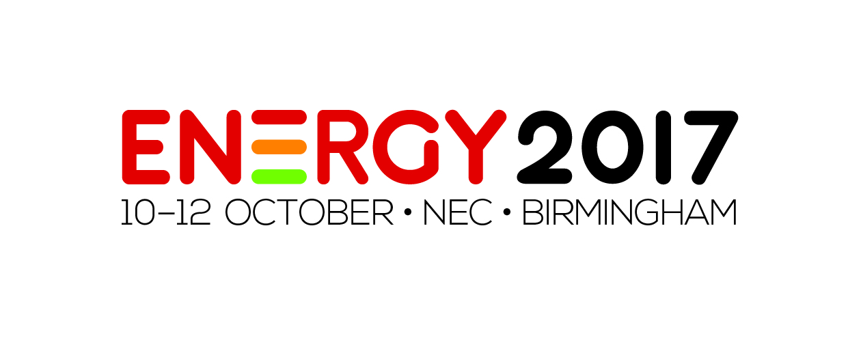

Press Release

28th June 2017

Feel the power at Energy 2017

Responding to visitor demand, Energy 2017 will feature even more innovative products and solutions.

Among the nine shows held during UK Construction Week at Birmingham’s NEC from 10th-12th October, Energy 2017 will be dedicated to renewables, innovation and power solutions within the building environment and will explore the reduction of costs through energy saving ideas.

As official content partner, The Renewable Energy Association (REA) - the trade association representing renewable energy producers and promoting the use of renewable energy in the UK - will deliver a programme of insightful talks revolving around biomass, wind and solar at the specially designed REA Theatre, sponsored by WElink. Over at the Energy Hub seminar theatre there will be sessions on sustainable heating, wellbeing and indoor air quality, while Npower will also be on hand to deliver educational, thought-provoking presentations that will challenge industry perceptions.

Furthermore, the winners from the Low CVP Low Carbon Champions Awards will be announced at Energy 2017 on the evening of Wednesday 11th October during a special presentation with categories ranging from cars to innovation, from fuels to publications. The awards will demonstrate outstanding and innovative practices in this growing industry sector.

Nathan Garnett, Event Director at UK Construction Week, said: “After the success of the show during the past two years, we are excited to be back again for the third time as the leading show of its type. This year we have introduced many new attractions and will provide many opportunities for topical debate on key industry themes. It presents a highly valuable occasion for those to mix with like-minded professionals and to stay connected to the latest advancements in the sector.”

Free to attend, Energy 2017 will help mechanical and electrical contractors, consultants, project managers, specifiers, distributors and installers uncover innovative new products, find out about the latest industry trends, identify new business opportunities and form vital strategic partnerships.

It’s free to attend Energy 2017 – Get your free ticket here:
www.energyliveshow.co.uk/register

Note to Editors

Energy 2017 is a show dedicated to renewables, innovation and power solutions within the building environment and will provide visitors with energy saving ideas to help them reduce costs. Part of UK Construction Week, the event will welcome those working in the energy sector with a passion to find out more about the latest developments.

For further information, please contact:

Michael Crane
Tel: 01733 294524
Email: michael@keystonecomms.co.uk

Leandra Graves
Tel: 01733 294524
Email: leandra@keystonecomms.co.uk
