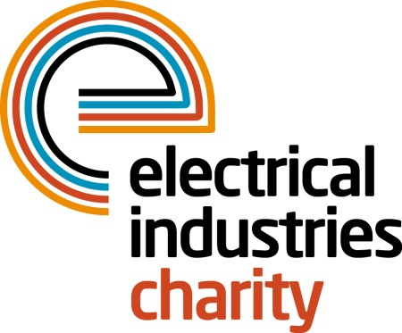
Press Release

19 June 2017

Create unforgettable memories with the Electrical Industries Charity

The Electrical Industries Charity is calling on the electrical sector to get fit this summer by joining one or all of its fantastic summer events.

Are you an enthusiastic individual who is looking for a challenge which would test your strength and stamina and push you to the limits? Why not join the Electrical Industries Charity’s Mudnificent 7 and prepare for a muddy 7k run through some of the most exciting and challenging obstacles. This unmissable race is taking place on Saturday 12 August 2017 at Heart Park, Warwickshire.

If this is not enough why not try the Tough Mudder and challenge your mental grit and overcome your biggest fears at the toughest obstacle course in the UK? At the Tough Mudder, you will have an opportunity to push yourself beyond your limits and step outside your comfort zone as you overcome over 20 obstacles. The Tough Mudder is taking place at various UK locations between 29 July 2017 and 24 September 2017.

Or if you think you can go further, and didn’t manage to secure your place on the public ballot you can be part of the EIC’s London Marathon team and start preparing to run the famous 26.2 miles at the Virgin Money London Marathon 2018. You will have a chance to be part of the most iconic event and raise the necessary funds for people in your industry. Don’t miss this one in a lifetime chance to do something unforgettable. Virgin Money London Marathon is taking place on Sunday 22 April 2018.

Or if running it is not for you why not get together for a game of golf? This year the Electrical Industries Charity is celebrating the 80th Anniversary of the National Golf Championship (formerly known as the Power of Golf.) You and your team of four can tee off at one of the best premier championship golf destinations in the UK while being part of this special day in golf history for only £690. The National Golf Championship is taking place on Thursday 28 September 2017 at the stunning 10,000 acres Forest of Arden Golf course, Warwickshire.

Join the Charity’s must-attend events and create some lifelong memories for years to come while supporting people in the electrical sector.

For further information, please contact Charlotte Laurent: fundraising@electricalcharity.org

www.electricalcharity.org

Note to editors
The Electrical Industries Charity is the national charity for the electrical, electronics and energy industries. It aims to look after people from these industries whenever they or their families need help with life’s challenges.

The charitable services are available to anyone who currently works or has worked in the very diverse and often converging industries, such as:
- Electrical contracting and facilities management
- Electrical and electronic manufacturing, wholesale, distribution and retail
- Electrical and mechanical engineering
- Lighting industry
- Generation, distribution and supply of electrical power, including nuclear and renewable energy

For further information about the Electrical Industries Charity please contact Keystone Communications:

Tracey Rushton-Thorpe Monika Gaubyte
Tel: 01733 294524 Tel: 01733 294524
Email: tracey@keystonecomms.co.uk Email: monika@keystonecomms.co.uk

