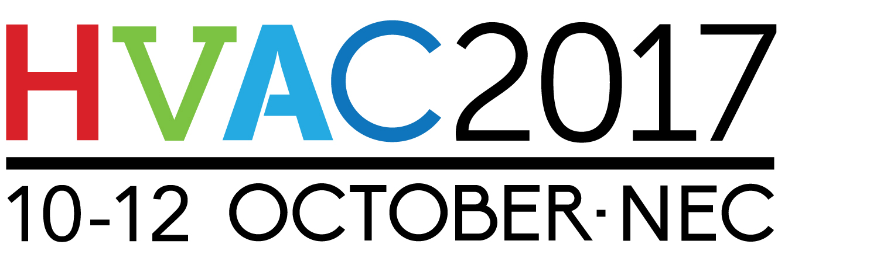

Press Release

28th June 2017

Stay cool and discover the hottest new technologies at HVAC 2017

Responding to visitor demand, HVAC 2017 will feature even more innovative products and solutions.

The show returns for its third year as part of UK Construction week and will take place at the NEC in Birmingham from 10th-12th October 2017. Visitors to HVAC 2017 will be spoilt for choice with access to eight other specialist shows all under one roof. Each show will be tailored to meet the needs and requirements of specifiers, engineers, installers, contractors and architects in their chosen areas of expertise and interest.

HVAC 2017 will provide a broad range of attractions for its visitors with insightful seminars at the HVAC hub, an exclusive innovation trail as well as invaluable and constructive one to one consultations with exhibitors and entertainment such as the beer and ale festival, casino night and award ceremonies.

The Carbon Trust will be delivering an educational seminar promoting debate and discussion on key themes such as micro-district ground source heating and its potential in providing a return on investment.

Attendees will be encouraged to undertake a journey of discovery on the exclusive Innovation Trail, uncovering the newly released products and solutions promising to transform the market.

The show is free for trade professionals, where they can come along and gain invaluable expert advice from a wide range of companies and organisations.

Nathan Garnett, Event Director of UK Construction Week reveals: “We’re delighted to be back for a third year. For 2017, the show returns on an even grander scale. HVAC 2017 is part of the largest trade show of its kind in the industry and we’ve introduced many new features which will no doubt prove popular. Join us for lively, educational debates on the subjects that matters to you.”

HVAC 2017 is supported by its associate partners - the Institution of Mechanical Engineers (IMECHE) Ground Source Heat Pump Association (GSHP), Federation of Environmental Trade Associations (FETA), Building Engineering Services Association (BESA), British Electrotechnical and Allied Manufacturers Association (BEAMA) and the British Compressed Air Society (BCAS), to name just a few.

It’s free to attend HVAC 2017 – Get your ticket here: www.hvaclive.co.uk/register

Note to Editors

HVAC 2017 attracts HVAC installers, contractors, specifiers and engineers from across the industry. Part of UK Construction Week, visitors will gain inspiration from key seminars at the HVAC hub, networking opportunities and consultations with exhibitors.

For further information, please contact:

Michael Crane
Tel: 01733 294524
Email: michael@keystonecomms.co.uk

Leandra Graves
Tel: 01733 294524
Email: leandra@keystonecomms.co.uk
