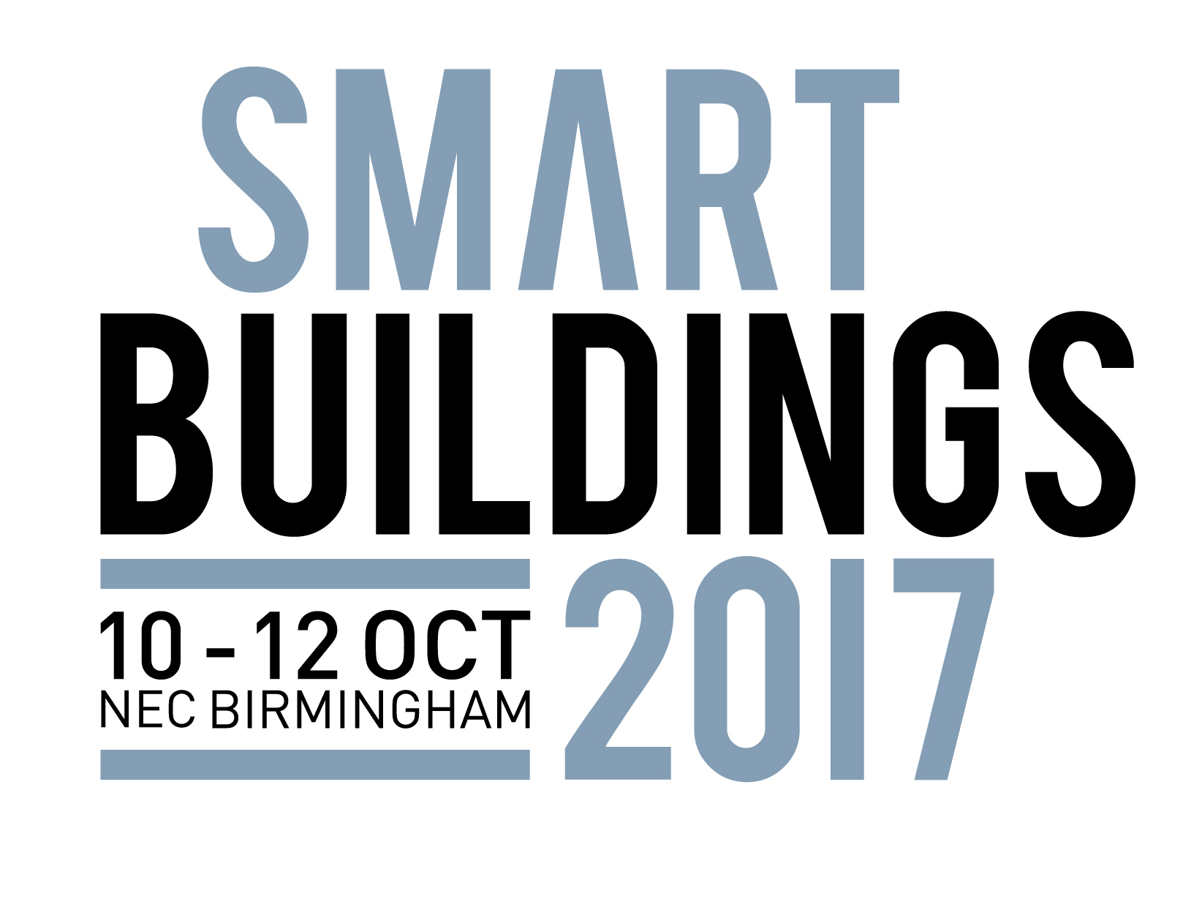

Press Release

28th June 2017

Get connected at Smart Buildings 2017

Responding to visitor demand, Smart Buildings 2017 will feature even more innovative products and solutions.

From 10th-12th October 2017, industry professionals will once again come together for the UK’s leading integrated built environment technologies event at the NEC in Birmingham.
Smart Buildings 2017 is one of nine exciting shows taking place across the three days and is dedicated to integrated building technology. Amongst the broad spectrum of topics covered will be workplace technology, access and security controls and home entertainment systems.

A stand-out attraction this year, the Innovation Trail will allow visitors to be amongst the first to explore the innovative and unique products and solutions set to transform the market.

This year’s event will also play host to the Voltimum Smart Solutions Awards on 11th October, with the winners announced during a special drinks reception. The awards will champion the installers, manufacturers and wholesalers leading the charge in the smart homes and buildings market. Award categories include Best Installer, Best Newcomer Installer, Best Project, Best Product, Best Manufacturer and Best Wholesaler and further information on the criteria for each can be found at www.voltimum.co.uk/content/smart-solutions-awards-2017. What’s more, the Voltimum theatre will host informative seminars on a wide range of topical issues from around the connected buildings industry.

Recognising the increasing influence of the smart buildings sector, a number of prominent organisations have announced their support for the Smart Buildings 2017, including The Royal Institute of British Architects (RIBA), the Electrical Contractors Association (ECA) and the Building Controls Industry Association (BCIA).

Nathan Garnett, Event Director, Smart Buildings 2017, said: “Building automation is playing an increasingly important role in both domestic and commercial installations. Visitors to Smart Buildings 2017 will discover cutting edge technologies linked to lighting, security, entertainment, heating and cooling, air quality, assisted living, the Internet of Things and more.”

Join like-minded professionals to stay abreast of the latest developments in your industry. Last year over 30,000 people did, including installers, specifiers, contractors and project managers. The three-day event represents an outstanding opportunity to connect with fellow trade professionals and is free to attend.
It’s free to attend Smart Buildings 2017 – Get your ticket here: www.smartbuildingslive.co.uk/register

Note to Editors

Smart Buildings 2017 will cover a spectrum of interconnected industries. Part of UK Construction week, Smart Buildings 2017 is the only construction event in the UK dedicated to commercial and residential integrated building technology. The three day event will be packed with inspirational content, thought provoking CPD sessions and leading industry names.

For further information, please contact:

Michael Crane
Tel: 01733 294524
Email: michael@keystonecomms.co.uk

Leandra Graves
Tel: 01733 294524
Email: leandra@keystonecomms.co.uk
