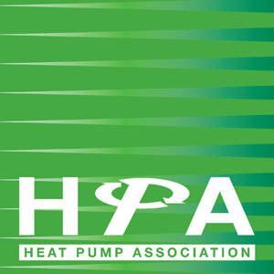

Press Release

24th May 2017

FETA and HPA sign DecarbHeat Declaration of Support

The Federation of Environmental Trade Associations (FETA) and the Heat Pump Association (HPA) have demonstrated their commitment to carbon free heating and cooling by signing the DecarbHeat Declaration of Support.

DecarbHeat is a European Heat Pump Association (EHPA) initiative that aims to turn the vision of a 100% carbon-free European heating and cooling sector by 2050 into reality.

The initiative includes an industry pledge signed by 25 representatives from leading organisations across the European thermal industry. By signing the pledge, these companies have demonstrated a willingness to take a prominent role in helping the industry make the all-important transition to carbon-free heating and cooling.

Supporting these signatories, nearly 50 other groups and associations from around Europe, including FETA and the HPA, have signed a separate declaration of support. This document represents an assurance that the associations and industry stakeholders back the DecarbHeat initiative and, where necessary, will take action to help realise the overriding goal of a 100% renewable heating and cooling sector.

Russell Beattie, Chief Executive of FETA, commented: “It is estimated that heating and cooling are responsible for 51% of Europe’s final energy demand. If the decarbonisation of Europe is ever to be fully realised, stakeholders from across the heating and cooling industry must come together and show a real commitment to lowering this figure. FETA and the HPA fully support the DecarbHeat initiative and its worthwhile objective of achieving carbon-free heating and cooling by 2050.”

The formal signatures were made public during the DecarbHeat Forum - a two day conference that took place in Brussels on 11-12 May and brought together over 30 speakers and 200 professionals involved in the heating and cooling sector.

www.feta.co.uk
www.heatpumps.org.uk

Note to Editors

The Heat Pump Association (HPA) is the UK’s leading authority on the use and benefits of heat pump technology and includes many of the country’s leading manufacturers of heat pumps, components and associated equipment.

The Association influences legislation and other matters that affect the interests of either the industry in general, or its members in particular. In addition, the HPA coordinates technical and market research into areas of mutual interest, identified by members with the aim of improving market opportunities for members, at home and abroad.

The HPA is part of FETA – the Federation of Environmental Trade Associations – a UK body representing the interests of over 400 manufacturers, suppliers, installers and contractors within heating, ventilating, building controls, refrigeration and air conditioning.

For further information, please contact Keystone Communications:

Michael Crane
Tel: 01733 294524
Email: michael@keystonecomms.co.uk

Tracey Rushton-Thorpe
Tel: 01733 294524
Email: tracey@keystonecomms.co.uk

