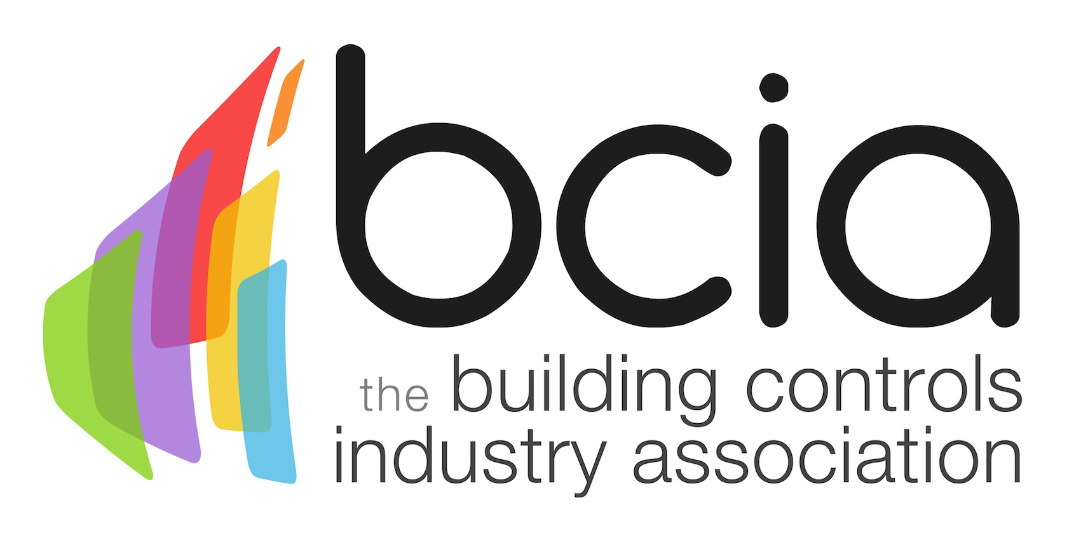

Press Release

09 August 2017

The smart effects of wellbeing in the workplace
The Building Controls Industry Association (BCIA) is highlighting the importance of occupant wellbeing in commercial buildings. As technology continues to evolve, there is an increasing focus on the wellness of individuals in the workplace, as well as the drive for smarter buildings which help boost productivity.
Historically, there was little thought given to occupants’ wellbeing by designers or contractors. However, wellbeing is now a hotly discussed topic across all industries and something which organisations must take seriously.

The WELL Building Standard is the first building standard to concentrate on the health and wellbeing of people. This has now been aligned with BREEAM – the global sustainability standard. The two together, now provide a central point for linking both wellness and sustainability, to achieve best practice.

Going forward, this standard will help building owners, facilities managers and HVAC engineers to determine future-proof solutions that assist with the wellbeing of individuals, in energy-efficient commercial buildings.

Research has proven that “well” employees at work, are both mentally and physically capable of doing their job, but are also more willing to develop their technical skills. Furthermore, individuals will demonstrate more loyalty to an organisation where they feel comfortable and happy in their environment.

The latest advancements in technology allow for smart building controls systems and sensors to be installed, which allow users to optimise their working environment. In conjunction with a Building Management System (BMS), heating, ventilation and air-conditioning can all be set to individuals’ personal preferences.

Dynamic buildings which are stimulating, with natural lighting and clean air, have been proven to ensure workers are more effective. As a consequence, overall business performance is likely to improve.
In today’s climate, buildings can’t remain stagnant. There needs to be an ongoing evolution of how buildings can adapt to occupants’ needs.

Many commercial buildings already feature the latest intelligent solutions, but this is still not common practice across the board. Wellbeing must be at the forefront of design to ensure a productive workforce, not just for now, but for the future.

Malcolm Anson, President of the BCIA said: “The importance of wellbeing within our industry is something we must fully embrace. No two people are the same, so why would we expect individuals to thrive in an environment which fails to meet their needs? We need to ensure the end user can perform at their optimum ability by providing flexible, user-control systems which promote a happy, healthy and sustainable working environment.”

www.bcia.co.uk

Note to editors
The Building Controls Industry Association (BCIA) represents the UK building controls and BEMS sector. With around 75 members accounting for 70% of the UK controls market, the BCIA is an influential group that promotes better specification, application and use of controls. The BCIA also offers its own training courses and the Building Controls Professional Assessment (BCPA).

For further information about the BCIA please contact Keystone Communications:

Tracey Rushton-Thorpe
Tel: 01733 294524
Email: tracey@keystonecomms.co.uk
Leandra Graves
Tel: 01733 294524
Email: leandra@keystonecomms.co.uk

