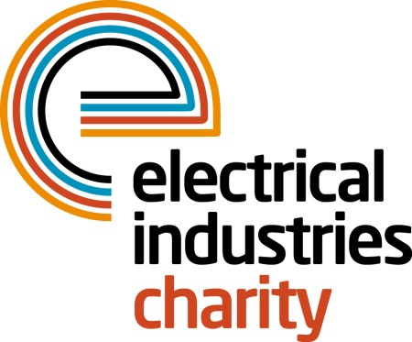
Press Release

17 August 2017

Take on a life-changing challenge with the Electrical Industries Charity

The Electrical Industries Charity is calling on the industry to get together and join their Challenge for a Cause campaign to help transform the lives of the Dickinson family.

Through its Challenge for a Cause, the Charity plans to raise £250,000 to purchase a house and work with industry partners to carry out any renovation work which is required to safeguard the future of Caz and her family.

As part of their Challenge for a Cause campaign, the Charity is set to take on the Arctic Adventure in 2018. So far, the Charity has 20 enthusiastic participants who are taking part in this once in a lifetime opportunity with the aim to show their support and raise vital funds for the Dickinson family. The Charity has raised £10,169 of their £250,000 goal and is currently looking for more participants to take part for this worthy cause.

There are many different ways where you can get involved and make a significant difference in someone’s lives. For example, you can join the Charity’s very own Managing Director, Tessa Ogle on the Arctic Adventure which takes place between 8-12 March 2018, where you will have an opportunity to experience cross-country skiing, snowshoeing and husky-sledding while helping the Charity to reach its fundraising goal.

You can also help the Charity to raise the roof for Caz and her family and make a long-lasting donation by sponsoring one brick at a time for only £25 for the Charity’s Raise the Roof campaign.

A personalised brick will allow you to put your name on this extraordinary project which will serve as a long-lasting tribute to you, or your sponsors and donors and your engraving will stay intact as long as the brick does. If you are a UK Income or Capital Gains taxpayer, don’t forget to add a Gift Aid to your donation. Gift Aid will allow the Charity to reclaim £0.25p for each pound you donate, which means that for each brick worth £25, the Charity will be able to claim £6.25 in Gift Aid at no additional cost to you.

No matter how big or small your participation is, it can have a significant impact on someone’s life. Join the Charity on this extraordinary challenge today and help the Dickinson family to have a happier future ahead.

For further information, or to take part, please contact Vicky Gray: vicky.gray@electricalcharity.org

www.electricalcharity.org

Note to editors
The Electrical Industries Charity is the national charity for the electrical, electronics and energy industries. It aims to look after people from these industries whenever they or their families need help with life’s challenges.

The charitable services are available to anyone who currently works or has worked in the very diverse and often converging industries, such as:
- Electrical contracting and facilities management
- Electrical and electronic manufacturing, wholesale, distribution and retail
- Electrical and mechanical engineering
- Lighting industry
- Generation, distribution and supply of electrical power, including nuclear and renewable energy

For further information about the Electrical Industries Charity please contact Keystone Communications:

Tracey Rushton-Thorpe Monika Gaubyte
Tel: 01733 294524 Tel: 01733 294524
Email: tracey@keystonecomms.co.uk Email: monika@keystonecomms.co.uk

