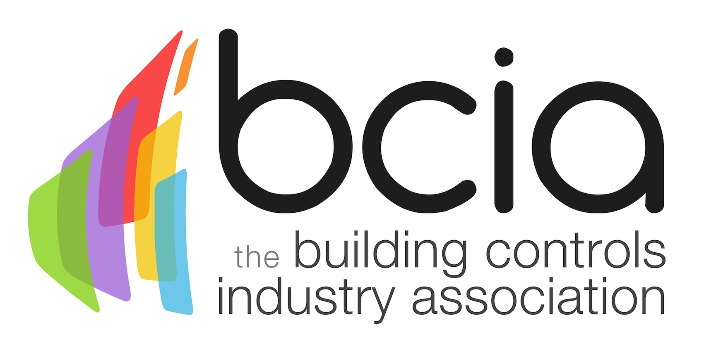

Press Release

12 September 2017

BCIA Management Committee welcomes three new members

The Building Controls Industry Association (BCIA) is pleased to announce the addition of three new members to the Management Committee. Following a vote by BCIA members, Sandy Damm, Terry Sharp and Paul Wetherfield have all been successfully appointed.

Terry Sharp, UK and Ireland Product Sales Manager at Johnson Controls, has worked in the controls industry for over 35 years. Terry’s expertise helps to bridge the gap between manufacturers and installers, to bring a rounded perspective to the challenges that are faced in today’s Building Management Systems (BMS) world.
Paul Wetherfield, CEO of Global Associates, has 15 years’ industry experience under his belt. Paul’s passion is driven by the lack of young engineers within the industry and as a result he’s shaped Global Associates around the development of young apprentices, which currently make up 15% of the workforce.

Sandy Damm, Managing Director of Sontay Ltd, has been employed within the building automation industry for over 15 years. Three years ago, Sandy launched the Sontay Academy, an education initiative which provides access to a wide range of courses designed to build knowledge, technical skills and contribute to CPD requirements.

Malcolm Anson, President of the BCIA says: “I am delighted to welcome three new members on board to join the BCIA Management Committee. Paul, Sandy and Terry will each bring something unique to the committee and are fully committed to addressing key industry challenges and strengthening the BCIA brand.”

www.bcia.co.uk

Note to editors
The Building Controls Industry Association (BCIA) represents the UK building controls and BEMS sector. With around 75 members accounting for 70% of the UK controls market, the BCIA is an influential group that promotes better specification, application and use of controls. The BCIA also offers its own training courses and the Building Controls Professional Assessment (BCPA).

For further information about the BCIA please contact Keystone Communications:

Tracey Rushton-Thorpe
Tel: 01733 294524
Email: tracey@keystonecomms.co.uk

Leandra Graves
Tel: 01733 294524
Email: leandra@keystonecomms.co.uk

