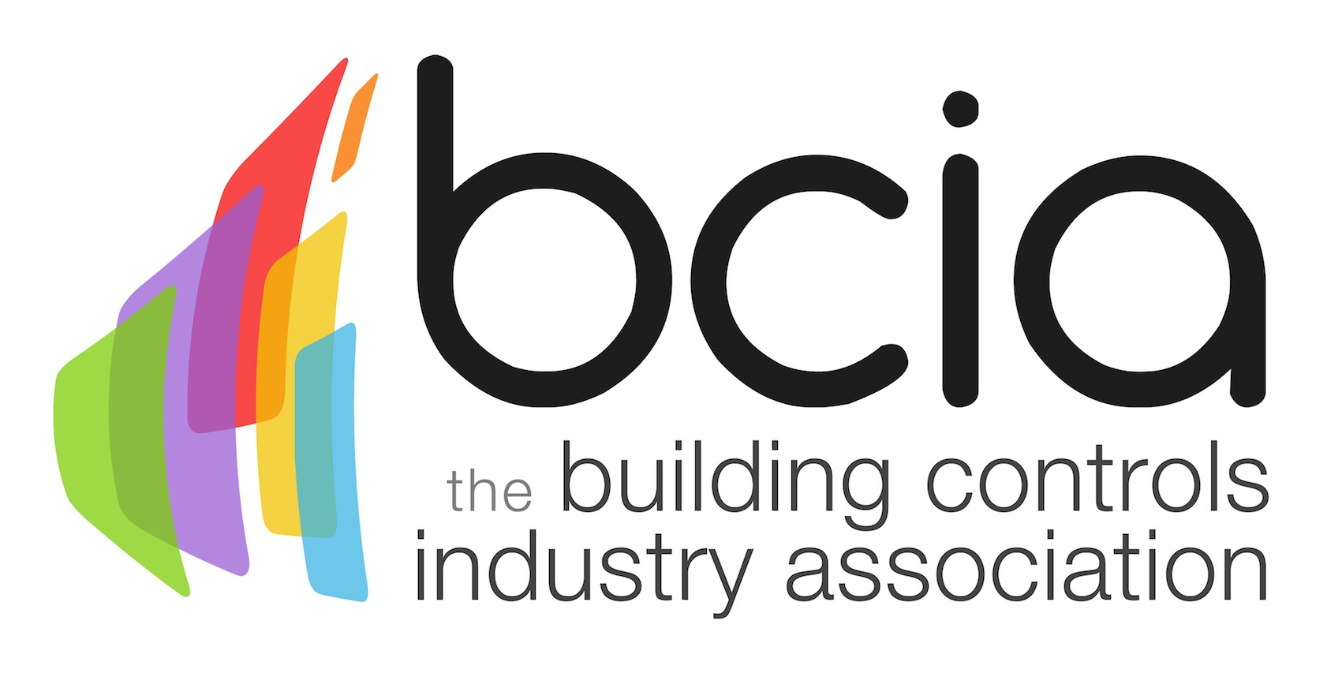

Press Release

11 October 2017

Entries are now open for the 2018 BCIA Awards

The most prestigious event in the industry’s calendar, the Building Controls Industry Association (BCIA) Awards is back for another year and entries are now open.

Don’t miss this opportunity to stand out from the rest of the industry by winning one of the coveted awards. Choose from one of eight categories which include Best Service and Maintenance Provider, Contribution to Training Award, Energy Management Award, Engineer of the Year Award; Independent Building Controls & BEMS Installer, Technical Innovation of the Year – Products, Young Engineer of the Year and Technical Innovation of the Year – Projects.

The BCIA Awards are now in their 12th successive year and continue to be greatly supported by the industry. This year’s Gold sponsors include CentraLine by Honeywell, Johnson Controls, Priva, Siemens Building Technologies, Trend and Western Automation.

Malcolm Anson, President of the BCIA says: “We are delighted to launch the BCIA Awards for 2018 which will once again be held at the Hilton Birmingham Metropole. The standard of entries in 2017 was extremely high which is testament to the sterling work which the building controls industry is involved in. I look forward to seeing more examples of this in 2018.”

The 2018 BCIA Awards, which take place on Thursday 10 May are free to enter and the deadline for entries is Friday 26 January. Put the date in your diary to ensure that you don’t miss out on this tremendous opportunity to join fellow industry professionals in celebrating the best of the best in the building controls industry.

www.bcia.co.uk

Note to editors
The Building Controls Industry Association (BCIA) represents the UK building controls and BEMS sector. With around 75 members accounting for 70% of the UK controls market, the BCIA is an influential group that promotes better specification, application and use of controls. The BCIA also offers its own training courses and the Building Controls Professional Assessment (BCPA).

For further information about the BCIA please contact Keystone Communications:

Tracey Rushton-Thorpe
Tel: 01733 294524
Email: tracey@keystonecomms.co.uk

Leandra Graves
Tel: 01733 294524
Email: leandra@keystonecomms.co.uk

