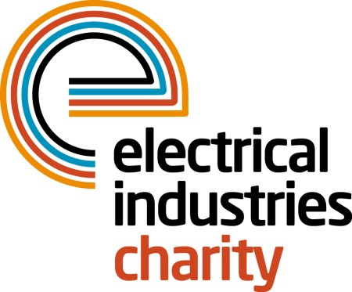
Press Release

20 September 2017

The Electrical Industries Charity takes on the Arctic Adventure

The Electrical Industries Charity together with Power Players 2017 winners Joseph Wu of T Clarke and Charlie Harwood of CEF are set to take on the Arctic Adventure to raise vital funds for the Dickinson family.

The Arctic Adventure is part of the Electrical Industries Charity’s second Challenge for a Cause campaign which aims to raise £250,000 to purchase a house and work with industry partners to carry any renovation work which is required to safeguard the future of Caz Dickinson and her family.

Recent Power Players winners won an opportunity to be part of the Charity’s Arctic Adventure and will embark on this unforgettable journey together with the Charity’s Managing Director Tessa Ogle to Finland in 2018.

There is still time for you to join the Electrical Industries Charity and its participants on this extraordinary adventure where you will experience cross-country skiing, snowshoeing and husky-sledding while helping the Charity to reach its fundraising goal. So far, The Charity has raised £35,863 of their £250,000 goal and are in need of your support to reach their target, because no matter how big or small your participation will be, it could make a huge impact in someone’s life.

This once in a lifetime experience is taking place between 8-12 March 2018. Limited spaces are still available so book your place now and do something incredible in 2018 by helping the Dickinson family to look forward to the future.

Managing Director, Tessa Ogle says: “We are thrilled by the tremendous response from participants who chose to take part in this unforgettable experience. Our Challenge for a Cause campaign aims to give the Dickinson family a brighter future ahead after many challenging years and will allow the family to focus on Caz’s development.”

Join the Charity on this once in a lifetime adventure and help people in your industry to have a better quality of life.

For further information or to book your place on this incredible adventure, please contact Charlotte Laurent: charlotte.laurent@electricalcharity.org

www.electricalcharity.org

Note to editors
The Electrical Industries Charity is the national charity for the electrical, electronics and energy industries. It aims to look after people from these industries whenever they or their families need help with life’s challenges.

The charitable services are available to anyone who currently works or has worked in the very diverse and often converging industries, such as:
- Electrical contracting and facilities management
- Electrical and electronic manufacturing, wholesale, distribution and retail
- Electrical and mechanical engineering
- Lighting industry
- Generation, distribution and supply of electrical power, including nuclear and renewable energy

For further information about the Electrical Industries Charity please contact Keystone Communications:

Tracey Rushton-Thorpe Monika Gaubyte
Tel: 01733 294524 Tel: 01733 294524
Email: tracey@keystonecomms.co.uk Email: monika@keystonecomms.co.uk

