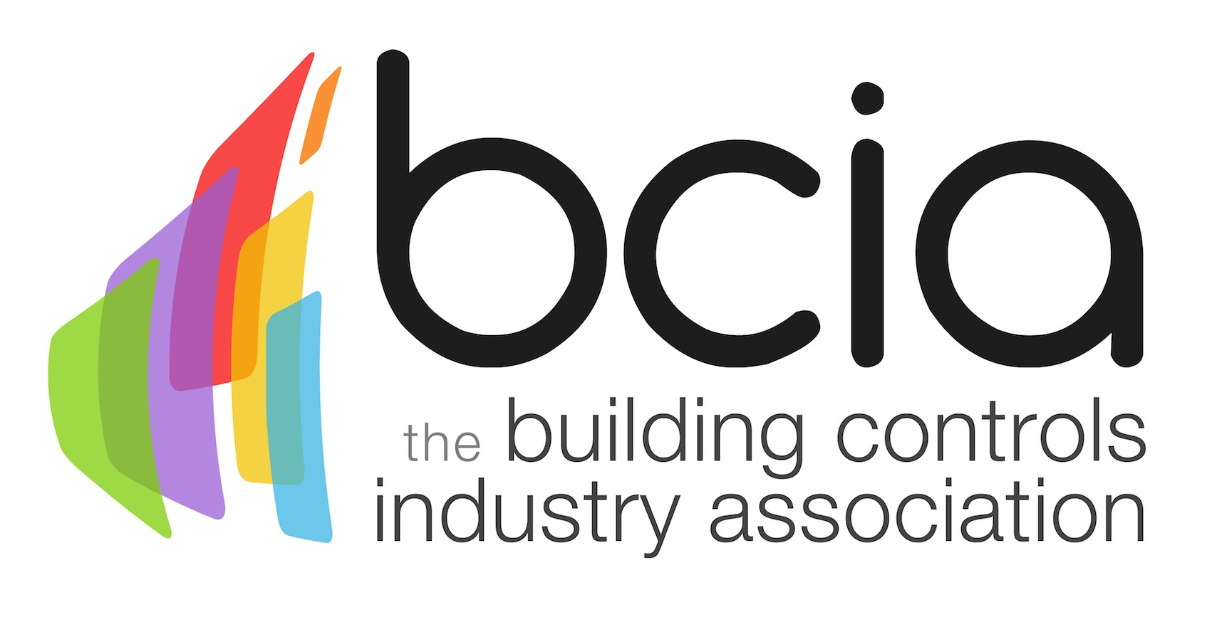

Press Release

08 November 2017

Could you be the next BCIA 2018 Awards winner?

Entries are now open for the most prestigious awards ceremony in the building controls industry - the Building Controls Industry Association (BCIA) 2018 Awards.

The BCIA 2018 Awards will once again celebrate industry achievements for the 12th consecutive year and will recognise innovation, product development, project delivery and excellent training in our sector.

Do you have a product or project which you feel deserves to be championed by the industry? Or do you have a young talented engineer within your company who you think deserves a worthy accolade and the prestige that goes alongside it.

Enter one or more of the eight categories at the BCIA 2018 Awards to be in with a chance to have your achievements celebrated. There are eight categories to choose from they include: Energy Management Award, Best Service and Maintenance Provider, Engineer of the Year Award; Technical Innovation of the Year – Products, Contribution to Training Award, Young Engineer of the Year and Technical Innovation of the Year – Projects, Independent Building Controls & BEMS Installer.

The winners of each category will enjoy the benefits of standing out amongst their industry peers while raising their profile for being crowned the best within the controls industry.

Entries close on Friday 26 January 2018, so it is essential to plan ahead and submit your entry on time. Book your table to attend the biggest and best event in the industry’s calendar and enjoy a three-course dinner, the awards ceremony and post show entertainment with networking.

The must-attend event of the year is taking place on Thursday 10 May 2018 at Hilton Birmingham Metropole.

Malcolm Anson, President of the BCIA, says: “Last year we saw many innovative businesses and bright individuals entering the BCIA Awards and getting recognised for their achievements and outstanding work in the industry.

“This is a unique opportunity to discover the latest innovations and projects that are redefining the future of the building controls industry.

“This year, we are looking forward to welcoming even more entries. All categories are free to enter, therefore if you have a project that you believe could be an award winner or you know of a talented engineer who deserves special recognition, I urge you to enter today.”

www.bcia.co.uk

Note to editors
The Building Controls Industry Association (BCIA) represents the UK building controls and BEMS sector. With around 75 members accounting for 70% of the UK controls market, the BCIA is an influential group that promotes better specification, application and use of controls. The BCIA also offers its own training courses and the Building Controls Professional Assessment (BCPA).

For further information about the BCIA please contact Keystone Communications:

Tracey Rushton-Thorpe
Tel: 01733 294524
Email: tracey@keystonecomms.co.uk

Leandra Graves
Tel: 01733 294524
Email: leandra@keystonecomms.co.uk

