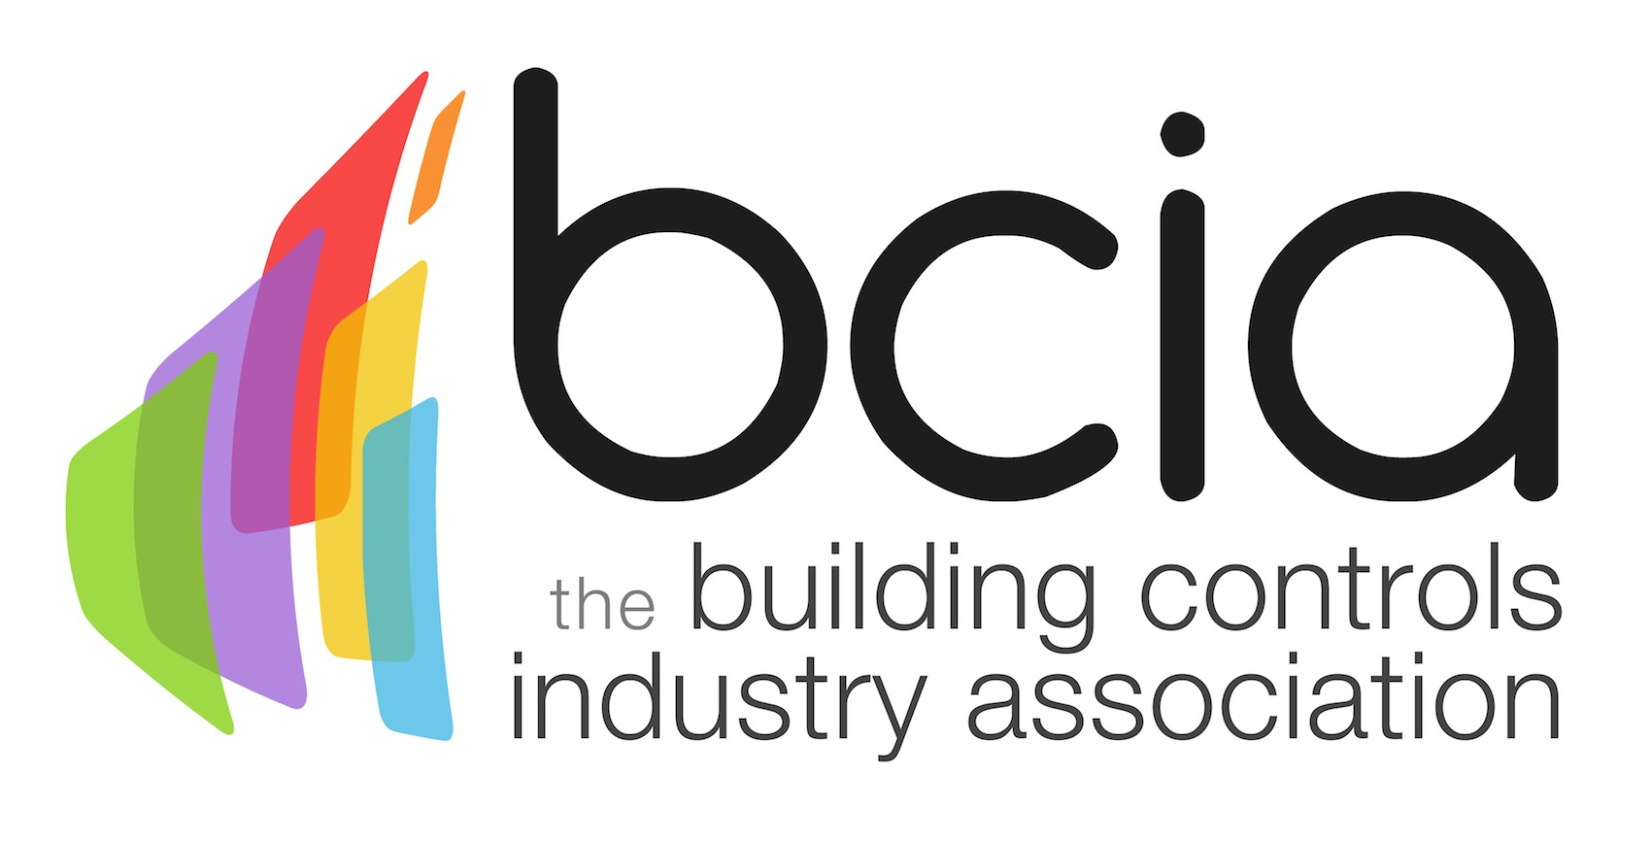

Press Release

08 January 2018

Last chance to enter the BCIA 2018 Awards

The Building Controls Industry Association (BCIA) is calling on the industry to seize the opportunity to enter the BCIA 2018 Awards. Time is running out to be in with a chance to be crowned the best within the building controls sector with entries closing on Friday 26 January 2018.

The BCIA 2018 Awards consists of various categories to enter which represent organisations, individuals or products, which have provided an exceptional contribution to the building controls sector over the past year.

Global Associates clinched the Independent Building Controls & BEMS Installer of the Year at the BCIA 2017 Awards and their Chief Executive, Paul Wetherfield reflected on their success.

“We understand that the BCIA is the driving force within our industry for best practice, as well as advancing the sector through training and many other conduits. For this reason, we recognised that any award received from the BCIA presented excellent value.

“It has been fantastic to reward the team with the award as it is a true recognition for the hard work that they have put in. It has also been invaluable to advertise this accomplishment, as well as confirming to our existing clients that their suspicions are correct - we are the best at what we do.

“The BCIA Awards is a fantastic evening and I have always enjoyed myself. It’s good to see old colleagues and share experiences with new friends too.”

It was also a night to remember for Stephen Astwood from Johnson Controls who was named Engineer of the Year at the BCIA 2017 Awards. Carla Dos Santos Sousa, from Johnson Controls said: “We are all so very proud of Stephen’s recognition.”

There are a range of awards to enter for 2018, including the Energy Management Award sponsored by Priva, Contribution to Training sponsored by Siemens Building Technologies, Best Service and Maintenance Provider, sponsored by Western Automation or the Young Engineer of the Year sponsored by the BCIA.

Do you think you, your company or one of your products deserves to be named the best in the industry? Enter today to be recognised for your achievements. The winners will be announced at the most prestigious awards ceremony in the building controls sector on Thursday 10 May 2018 at the Hilton Birmingham Metropole.

To see the full list of award categories and to enter – visit the website: https://bcia.co.uk/awards/categories/

Note to editors
The Building Controls Industry Association (BCIA) represents the UK building controls and BEMS sector. With around 75 members accounting for 70% of the UK controls market, the BCIA is an influential group that promotes better specification, application and use of controls. The BCIA also offers its own training courses and the Building Controls Professional Assessment (BCPA).

For further information about the BCIA please contact Keystone Communications:

Tracey Rushton-Thorpe
Tel: 01733 294524
Email: tracey@keystonecomms.co.uk

Leandra Graves
Tel: 01733 294524
Email: leandra@keystonecomms.co.uk

