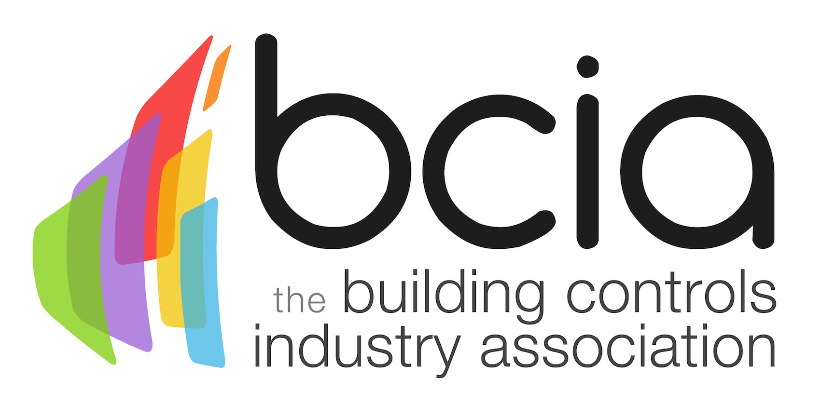

Press Release

06 December 2017

Time is running out to enter the BCIA 2018 Awards

The BCIA 2018 Awards return for a 12th successive year which will bring industry professionals under one roof to celebrate innovation, product development, project delivery and excellent training in the building controls sector.

The awards consist of eight categories - they are free to enter and not restricted to BCIA members. The BCIA 2018 Awards offer a unique opportunity for outstanding work and contribution to the controls industry to be recognised and projected to a captive and relevant audience.

Seize the day as entries close on Friday 26th January 2018. The winners will be revealed at the prestigious ceremony on Thursday 10th May 2018 at the Hilton Birmingham Metropole.

For those who have demonstrated professionalism, commitment and understanding of clients’ needs, why not enter the Independent Building Controls and BEMS Installer of the Year, sponsored by CentraLine.

Or if you are a manufacturer, installer or team who has completed a project which demonstrates how building controls or BEMS have been applied to increase energy efficiency in a building, submit your entry for the Energy Management Award, as sponsored by Priva.
Perhaps, you, or your company has contributed to training on the use of building controls or BEMS? If so, you could claim honours in the Contribution to Training category - sponsored by Siemens Building Technologies.

Sponsored by Johnson Controls, The Technical Innovation of the Year – Projects accolade is bestowed to the project installer/team which best demonstrates innovative thinking on the installation or service/maintenance of building controls/BEMS.

Whereas, Technical Innovation of the Year – Products, sponsored by BCIA, is presented to the most innovative building controls/BEMS product development introduced in the past 12 months.

If you have demonstrated an outstanding level of customer care to the controls sector, the Best Service and Maintenance Provider category sponsored by Western Automation could highlight examples of this.

Could you be the next Engineer of the Year? This category is sponsored by Trend Controls Systems. Or perhaps you know of a young engineer under the age of 30 who has demonstrated exceptional achievement through successful participation of the BCIA Training Programme? If so, why not nominate them for the Young Engineer of the Year category, sponsored by BCIA.

To find out more and to enter – visit the website: https://bcia.co.uk/awards/categories/

Note to editors
The Building Controls Industry Association (BCIA) represents the UK building controls and BEMS sector. With around 75 members accounting for 70% of the UK controls market, the BCIA is an influential group that promotes better specification, application and use of controls. The BCIA also offers its own training courses and the Building Controls Professional Assessment (BCPA).

For further information about the BCIA please contact Keystone Communications:

Tracey Rushton-Thorpe
Tel: 01733 294524
Email: tracey@keystonecomms.co.uk

Leandra Graves
Tel: 01733 294524
Email: leandra@keystonecomms.co.uk

