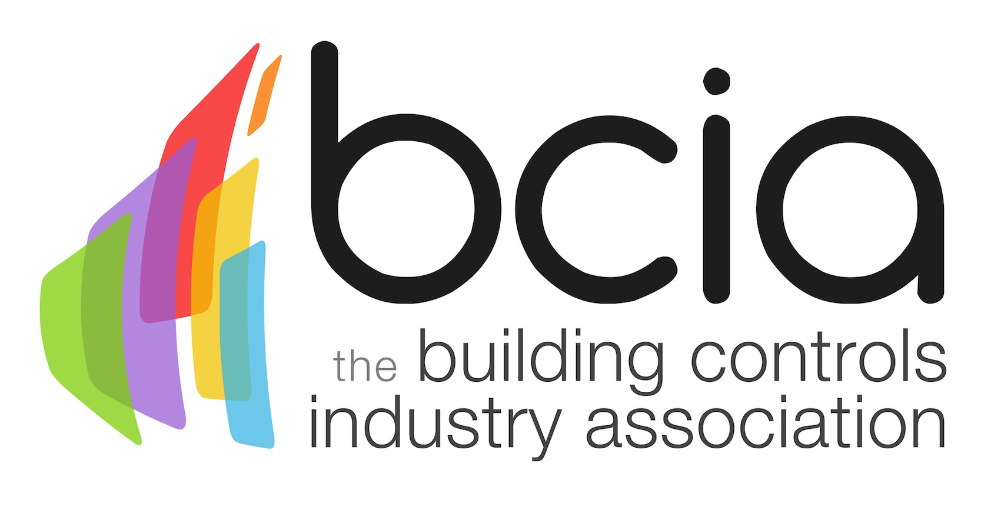

Press Release

18 January 2018

New Building Controls Integrator ECS Card Launched

The Building Controls Industry Association (BCIA) is delighted to announce the launch of the new Building Controls Integrator ECS card. The BCIA and ECS have worked in partnership to introduce the card which meets the need for the growing body of control engineers to gain appropriate recognition for the control integrator skills they have acquired.

The new card allows control engineers to gain access to contracts and sites which specify ECS cards as mandatory and gives an advantage over competitors who can’t prove their accomplishments. What’s more, it demonstrates to the industry, employers and clients that they have the skills in line as listed on the card.

The card is now available for applications via the ECS website. To be eligible, applicants must hold a BCIA Technical Certificate - which is awarded on completion of the recently updated BCM01, BCM02 and BCM03 courses.

The BCIA has comprehensively revamped the building control training courses for 2018 which have been devised to help professionals build-on their expertise while gaining valuable knowledge of the latest technology which can be utilised in the workplace.

Courses are available to all levels of those on the building controls ladder. The courses run over two days, ensuring that there is minimal disruption to the delegates’ work schedule.

Applicants for the Building Controls Integrator ECS card must also hold a current ECS Health, Safety and Environmental Assessment and a formal BS7671 qualification in the current edition of the wiring regulations (currently BS7671: 2008, 17th edition).

Each applicant will have their skills assessed and certified based on the qualifications evidence they submit before a card can be issued.

David Thomas, ECS Strategic Development Manager said: “We are very pleased to have worked in partnership with the BCIA to launch the new Building Controls Integrator ECS card. We feel this offers a fantastic opportunity for building controls professionals to prove their skills to the industry and show their card with pride.”

To find out more and apply for your ECS card today, visit the BCIA website.

www.bcia.co.uk

Note to editors
The Building Controls Industry Association (BCIA) represents the UK building controls and BEMS sector. With around 75 members accounting for 70% of the UK controls market, the BCIA is an influential group that promotes better specification, application and use of controls. The BCIA also offers its own training courses and the Building Controls Professional Assessment (BCPA).

For further information about the BCIA please contact Keystone Communications:

Tracey Rushton-Thorpe
Tel: 01733 294524
Email: tracey@keystonecomms.co.uk

Leandra Graves
Tel: 01733 294524
Email: leandra@keystonecomms.co.uk

