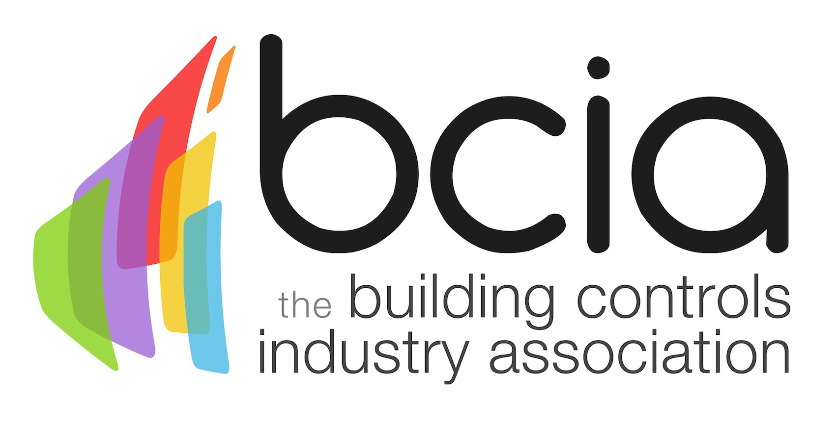

Press Release

23 November 2017

BCIA announces new training courses for 2018

The Building Controls Industry Association (BCIA) is pleased to announce the release dates for the new and improved building control training courses for 2018.

The brand-new courses will offer building controls professionals an opportunity to develop their skills and gain valuable knowledge of the latest technology which they will be able to utilise in their workplace.

The BCM01-06 courses cover a wide range of topics which incorporate the latest technical information from the building controls sector which helps engineers, installers, and building owners to further their knowledge and skills within the industry.

Courses are available to all levels of those who are on the building controls ladder. All of the six courses now run over two days, ensuring there is minimal disruption to delegates work schedule and time spent away from the workplace.

If you are starting out in the controls industry or looking to develop on your current knowledge, you can choose to take the BCM01 training course of Fundamentals of HVAC & Building Technology. The BCM01 training course will give you an overview of the systems and technologies used in the HVAC industry and includes the use of building controls and building management systems.

Or if you are an engineer or technician, who has over one year’s experience within the industry and have already completed BCM01, you can book onto BCM02 and BCM03 and learn more about Measuring & Control Technology and Hydraulics in Building Services. On successful completion of BCM01-BCM03, the Technical Certificate will be awarded.

For professionals who are looking to expand their knowledge further, the BCIA offers BCM04-BCM06 which covers topics including Control Function in Heating Plants, Control of Ventilation and Air Conditioning and Control of Cooling Systems. The Advanced Technical Certificate will be gained to those who pass each BCM04-BCM06.

Malcolm Anson, President of the BCIA, says: “We are delighted to announce the launch of our comprehensively updated courses for the upcoming year. The new courses will allow everyone within the controls industry to gain the valuable skills needed for the buildings of tomorrow.”

January 2018 sees the new courses commence with BCM01 and BCM04 the first offerings to choose from. Places are filling up fast, book your place today and start the new year by taking your skills further.

For further information or to book your course today, please contact Hayley Hopkins: hayley@keystonecomms.co.uk

www.bcia.co.uk

Note to editors
The Building Controls Industry Association (BCIA) represents the UK building controls and BEMS sector. With around 75 members accounting for 70% of the UK controls market, the BCIA is an influential group that promotes better specification, application and use of controls. The BCIA also offers its own training courses and the Building Controls Professional Assessment (BCPA).

For further information about the BCIA please contact Keystone Communications:

Tracey Rushton-Thorpe
Tel: 01733 294524
Email: tracey@keystonecomms.co.uk

Leandra Graves
Tel: 01733 294524
Email: leandra@keystonecomms.co.uk

