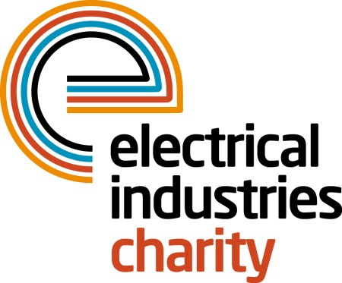
Press Release

30 October 2017

Providing essential support for people with autism

The Electrical Industries Charity has joined forces with the National Autistic Society (NAS) to provide essential support for individuals and their families who are dealing with autism.

Autism is a lifelong, developmental disability that affects how a person communicates with and relates to other people, and how they experience the world around them. Autistic people see, hear and feel the world differently to others and although all autistic people share certain difficulties, being autistic will affect them in different ways.

The Electrical Industries Charity has therefore launched the Employee and Family Support Programme and partnered with the NAS to assist employees and their families who are affected by autism, offering services which include telephone advice, a parent to parent emotional support network and financial assistance.

Recently the Charity has helped an electrician, John, who approached the Charity for help after seeing the Charity’s information on the NAS website.

One of John’s children has already been diagnosed with autism, but due to severe behavioural problems, he needs to be managed by both of his parents when visiting doctors. Their other three children are being carefully looked at as they could also be on the autism spectrum.

The company who John worked for had not been very supportive, and therefore he lost his job. He managed to find another one very quickly but due to a lack of steady income, he fell behind in paying for their family car and it was repossessed. The large people carrier was essential for him and his family to take his children to a hospital appointment.

The Charity has assisted the family by providing them with a family car. The Electrical Industries Charity has also referred John to the NAS who are supporting the family through the ongoing diagnosis process, providing information and support as well as putting the family in touch with others in a similar situation.

Through its support services the Charity ensures that those who are dealing with autism are not alone and that they all get the support they need to help them through difficult situations in their lives.

For further information, please contact Vicky Gray: vicky.gray@electricalcharity.org

www.electricalcharity.org

Note to editors
The Electrical Industries Charity is the national charity for the electrical, electronics and energy industries. It aims to look after people from these industries whenever they or their families need help with life’s challenges.

The charitable services are available to anyone who currently works or has worked in the very diverse and often converging industries, such as:
- Electrical contracting and facilities management
- Electrical and electronic manufacturing, wholesale, distribution and retail
- Electrical and mechanical engineering
- Lighting industry
- Generation, distribution and supply of electrical power, including nuclear and renewable energy

For further information about the Electrical Industries Charity please contact Keystone Communications:

Tracey Rushton-Thorpe Monika Gaubyte
Tel: 01733 294524 Tel: 01733 294524
Email: tracey@keystonecomms.co.uk Email: monika@keystonecomms.co.uk

