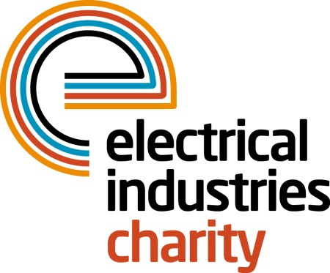
Press Release

23 October 2017

Crucial support for employees and their families

The Electrical Industries Charity has launched the Employee and Family Support Programme which aims to help employees and their families with challenging life situations in their time of need.

In the electrical sector, many people are struggling with a wide range of issues. This could be due to caring for a loved one, going through a relationship breakdown, having financial problems or dealing with mental health issues. But not many of these people who are struggling feel comfortable sharing their problems and therefore continue to suffer on their own in silence.

The Electrical Industries Charity understands that those who are suffering in silence need support to help them take the first step in overcoming their life challenges and therefore launched the Employee and Family Support Programme to help people in the electrical and energy sectors to look forward to the future.

The Charity’s Programme offers employees and their families vital support through its services including a confidential helpline and free telephone counselling sessions, debt solutions, financial assistance and grants, legal advice and career advice.

Starting out with the Employee and Family Support Programme is easy because the Charity works with you to provide information which is tailored to your staff. All the services which the Charity offers are also free of charge, therefore, as soon as you sign up we will be looking out for your employees and their loved ones.

Managing Director, Tessa Ogle, says: “We all go through difficult circumstances in our lives and we all know how important it is to have someone there who you can talk to when times get tough.

“In our industry, there are many people who are struggling with a wide range of challenging situations which are restricting them from having the fulfilling life they deserve. This is why we have launched our Employee and Family Support Programme to provide support and assist them in each step of the way towards creating a better future for themselves.”

Sign up to the Employee and Family Support Programme today and help someone in your industry to have the life they deserve because people who work in the electrical industry should never be alone.

For further information, or to take part, please contact Vicky Gray: vicky.gray@electricalcharity.org

The Confidential Helpline number is: 0800 652 1618.

www.electricalcharity.org

Note to editors
The Electrical Industries Charity is the national charity for the electrical, electronics and energy industries. It aims to look after people from these industries whenever they or their families need help with life’s challenges.

The charitable services are available to anyone who currently works or has worked in the very diverse and often converging industries, such as:
- Electrical contracting and facilities management
- Electrical and electronic manufacturing, wholesale, distribution and retail
- Electrical and mechanical engineering
- Lighting industry
- Generation, distribution and supply of electrical power, including nuclear and renewable energy

For further information about the Electrical Industries Charity please contact Keystone Communications:

Tracey Rushton-Thorpe Monika Gaubyte
Tel: 01733 294524 Tel: 01733 294524
Email: tracey@keystonecomms.co.uk Email: monika@keystonecomms.co.uk

