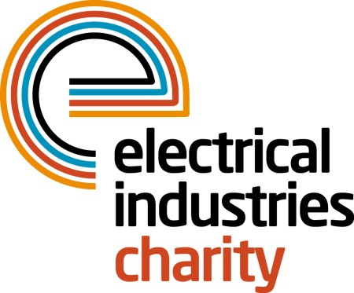
Press Release

04 January 2018

Are you up for a life-changing challenge in 2018?

The Electrical Industries Charity is offering a once in lifetime opportunity to visit one of the seven wonders of the world while showing your support for the Dickinson family.

You could take on the Great Wall of China trek in 2018 which stretches 6000 km in a dotted line across China. During this trek, you will have a chance to conquer the imperial masterpiece of the Ming dynasty in support of the Electrical Industries Charity while combating the elements of thousands of steps as you trek through woodland and terraced farmland, following the contours of the beautiful hills and mountains in remote areas north of Beijing. This unforgettable experience is taking place between 13-22 September 2018 - all you need to do is to sign up and raise £3,150.

Or why not join the Charity’s Managing Director Tessa Ogle on the journey to the Lost City of the Inca – Machu Picchu. This adventure of a lifetime will allow you to experience one of the most iconic sites in South America while trekking through the Peruvian Andes. This 10-day challenge will include trekking through Inca-paved paths and steps. The route will take you through lush cloud forest to the demanding Dead Woman’s Pass which stands at 4200m and the Sun Gate which overlooks the magical Machu Picchu. This incredible adventure is taking place between 27 October 2018 – 05 November 2018. Permits to the Inca Trail are restricted and must be secured months in advance so sign up in good time. The fundraising target for this challenge is £4,000.

Both of the challenges are part of the Charity’s Challenge for a Cause campaign which aims to raise £250,000 that will help to secure a long-lasting home for the Dickinson family and help Caz Dickinson with her development. You can find out more about the Dickinson family, by visiting the Charity’s official website: https://www.electricalcharity.org/index.php/fundraising/challenge-for-a-cause/2017-2018

Only 10 places are available on each of the challenges. Therefore, book your place today and do something incredible in 2018 by joining one or both of the challenges, get fit and lose a pound for a £1 while creating memories which will last for many years to come.

For further information, or to take part, please contact Charlotte Laurent: charlotte.laurent@electricalcharity.org

www.electricalcharity.org

Note to editors
The Electrical Industries Charity is the national charity for the electrical, electronics and energy industries. It aims to look after people from these industries whenever they or their families need help with life’s challenges.

The charitable services are available to anyone who currently works or has worked in the very diverse and often converging industries, such as:
- Electrical contracting and facilities management
- Electrical and electronic manufacturing, wholesale, distribution and retail
- Electrical and mechanical engineering
- Lighting industry
- Generation, distribution and supply of electrical power, including nuclear and renewable energy

For further information about the Electrical Industries Charity please contact Keystone Communications:

Tracey Rushton-Thorpe Monika Gaubyte
Tel: 01733 294524 Tel: 01733 294524
Email: tracey@keystonecomms.co.uk Email: monika@keystonecomms.co.uk

