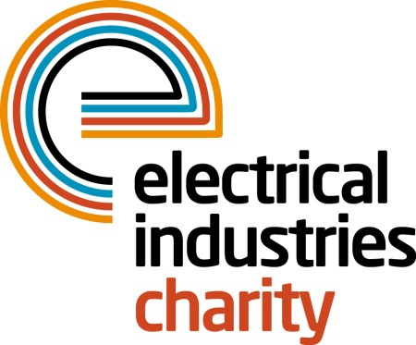
Press Release

30 November 2017

It is time to end the stigma of mental health

The Electrical Industries Charity wants to end the stigma of mental health by offering vital support services for people who are experiencing mental health problems in the electrical sector.

Many of you may not be aware that 1 in 4 of us will experience mental health problems in our lifetime. According to the Mental Health Foundation study, 65% of Britons have experienced mental health problems like a panic attack or depression in their life.

Time to Change’s ‘State of Stigma’ survey also revealed that 90% of people with mental health problems are still experiencing some form of stigma, whether from friends and family or at work.

The stigma of mental health issues is a serious barrier and one which we need to overcome. The Electrical Industries Charity’s latest records show that in the electrical sector only 5% of people share their problems with their partner.

To address these concerning figures, the Charity launched its Employee Assistance Programme which offers crucial support for people in our sector. In the past year, the Charity assisted over 4,000 people in the electrical sector who were in need of crucial support.
Danny’s story is one of many examples which highlights how the right level of support for someone who is suffering in silence could help to change their way of life.
Danny was a qualified electrician who suffered a complete mental breakdown following the loss of his business and subsequent divorce. He was put on a high-level of medication which left him unable to work due to the residual anxiety and depression. His extra discretionary benefit was also stopped which left him with a £400 per month shortfall. It was at this point that he decided to contact the Charity for support. The Charity put Danny on immediate one to one counselling, provided financial support to cover his rent and helped him to register with a work scheme. They also provided him with all of the necessary tools that were needed to help him to continue with his career as a successful electrician.
Danny was able to access support when he needed it most and is now on his journey to recovery, but there are many more who still need our support.
Sign up for the Charity’s Employee Assistance Programme today and help to break the silence while ending the stigma of mental health issues in our sector.
For further information, or to take part, please contact Vicky Gray: vicky.gray@electricalcharity.org

www.electricalcharity.org

Note to editors
The Electrical Industries Charity is the national charity for the electrical, electronics and energy industries. It aims to look after people from these industries whenever they or their families need help with life’s challenges.

The charitable services are available to anyone who currently works or has worked in the very diverse and often converging industries, such as:
- Electrical contracting and facilities management
- Electrical and electronic manufacturing, wholesale, distribution and retail
- Electrical and mechanical engineering
- Lighting industry
- Generation, distribution and supply of electrical power, including nuclear and renewable energy

For further information about the Electrical Industries Charity please contact Keystone Communications:

Tracey Rushton-Thorpe Monika Gaubyte
Tel: 01733 294524 Tel: 01733 294524
Email: tracey@keystonecomms.co.uk Email: monika@keystonecomms.co.uk

