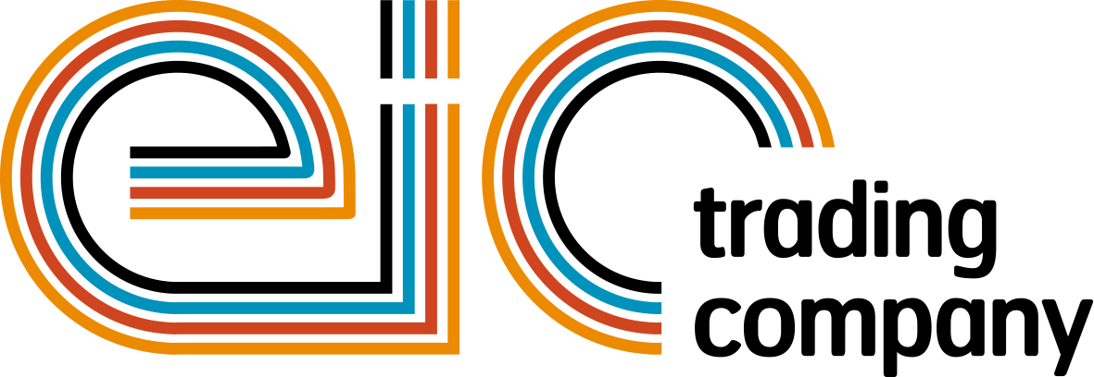

Press Release

04 January 2018

Tremendous success at powerBall 2017- Friday Night Fever

The Electrical Industries Trading Company, in support of the Charity, is delighted to announce that the phenomenal dance extravaganza – powerBall 2017-raised over £140,000. On top of that, on the night, 51 people pledged to raise £1,000 each for the Charity in the next 12 months through individual fundraising.

Since the very first inaugural Festival Dinner which took place in 1908, powerBall continues to bring hundreds of industry professionals together under one roof to celebrate a successful year in the electrical sector and this year’s event lived up to its reputation.

The Friday Night Fever themed event brought New York City back to life where guests had a chance to re-live their disco days with a blistering soundtrack of hits including Night Fever, More Than A Woman, If I Can’t Have You and Stayin’ Alive. Guests on the night also witnessed the phenomenal performance of a Saturday Night Fever tribute show choreographed by Nikki Trow.

Hundreds of guests danced the night away to the brand-new band Madhen and DJ Laura and enjoyed the best entertainment from the UK’s leading impressionist and entertainer - Mike Osman.

In addition, dozens of people who attended this spectacular event got involved in the Charity’s Raise the Roof ‘One brick at a time’ campaign by donating £25 each to the Electrical Industries Charity, allowing them to buy a personalised brick which will go towards building a house for Caz Dickinson and her family. The Charity aims to raise £250,000 and work with industry partners to carry out any renovation work which is required to safeguard the future of Caz and her family.

Managing Director, Tessa Ogle says: “powerBall 2017 once again proved to be a huge success, bringing over 750 guests together under one roof for the most unforgettable night in the electrical sector.

“We would like to say a big thank you to our headline sponsor City Electrical Factors (CEF) and every one of you for your continuing support. Without you, we would not be able to help those who are in need of our support.”

Next year, powerBall will take place on Friday 09 November at the Grosvenor House Hotel, London.

www.eictradingco.org

Note to editors
powerBall 2017 is being run by The Electrical Industries Trading Company Limited which is a wholly owned subsidiary of the Electrical Industries Charity.

The Electrical Industries Charity is the national charity for the electrical, electronics and energy industries. It aims to look after people from these industries whenever they or their families need help with life’s challenges.

The charitable services are available to anyone who currently works or has worked in the very diverse and often converging industries, such as:
- Electrical contracting and facilities management
- Electrical and electronic manufacturing, wholesale, distribution and retail
- Electrical and mechanical engineering
- Lighting industry
- Generation, distribution and supply of electrical power, including nuclear and renewable energy

www.electricalcharity.org

For further information about powerBall 2017 please contact Keystone Communications:

Monika Gaubyte
Tel: 01733 294524
Email: monika@keystonecomms.co.uk

Tracey Rushton-Thorpe
Tel: 01733 294524
Email: tracey@keystonecomms.co.uk

