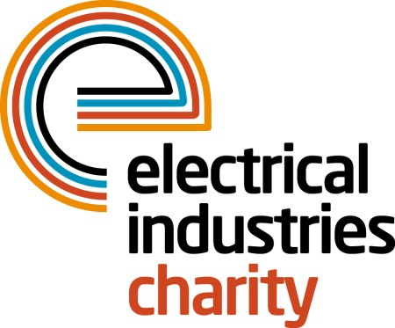
Press Release

09 September 2017

Power Players 2017 winners announced

Two lucky high flyers, Joseph Wu, a mechanical engineer at T Clarke, and Charlie Harwood, a branch manager at CEF, were announced as the inaugural winners of Power Players 2017 at ED & I Expo on Thursday 7 September 2017.

Power Players is a brand-new industry-wide initiative which was created to find and promote young inspirational talent within the electrical and building controls industry.

The initiative was run by the ECA between April and July this year and the Electrical Industries Charity worked in partnership with them and other industry organisations to provide recognition for tomorrow’s bright young stars.

The Electrical Industries Charity’s Managing Director Tessa Ogle was among the independent judging panel which consisted of Steve Martin of the Electrical Contractors’ Association, Russell Beatie, the Chief Executive of the Federation of Trade Association (FETA) and Margaret Fitzsimons of the Electrical Distributors Association (EDA).

The winners, Joseph Wu of T Clarke, and Charlie Harwood won top industry prizes including a once in a lifetime networking trip to the NECA conference in Philadelphia, the Charity’s scholarship grant entitlement and the chance to join the Charity’s Arctic Adventure in March 2018. Both of the winners will embark on the adventure of a lifetime while being part of the Charity’s Challenge for a Cause campaign which aims to help the Dickinson family to have a brighter future.

Managing Director, Tessa Ogle says: “Power Players was a fantastic initiative that outlined the outstanding contributions of bright young people across the industry and identified the future leaders of tomorrow.

“We would like to say huge congratulations to both talented individuals for winning this year’s Power Players initiative and to all of the finalists. We are looking forward to seeing both of the winners on our Arctic Adventure in 2018.”

Videos from all of the finalists can still be found on the official Power Players website: www.powerplayers.uk.com

For further information, or to take part, please contact Vicky Gray: vicky.gray@electricalcharity.org

www.electricalcharity.org

Note to editors
The Electrical Industries Charity is the national charity for the electrical, electronics and energy industries. It aims to look after people from these industries whenever they or their families need help with life’s challenges.

The charitable services are available to anyone who currently works or has worked in the very diverse and often converging industries, such as:
- Electrical contracting and facilities management
- Electrical and electronic manufacturing, wholesale, distribution and retail
- Electrical and mechanical engineering
- Lighting industry
- Generation, distribution and supply of electrical power, including nuclear and renewable energy

For further information about the Electrical Industries Charity please contact Keystone Communications:

Tracey Rushton-Thorpe Monika Gaubyte
Tel: 01733 294524 Tel: 01733 294524
Email: tracey@keystonecomms.co.uk Email: monika@keystonecomms.co.uk

