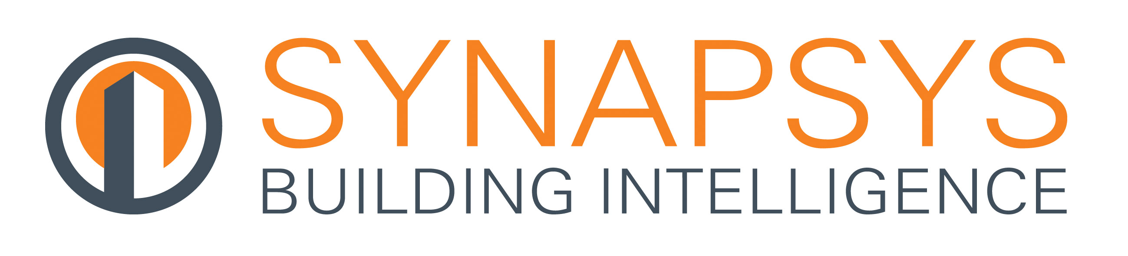

Press Release

27 October 2017

Stay connected with Synapsys Solutions at Smart Buildings Show

Synapsys Solutions will deliver two insightful CPD-Accredited presentations at the Smart Buildings Show which takes place at the Barbican in central London on 08-09 November. This will be the UK’s first dedicated smart buildings event.
The first presentation from Synapsys Solutions will focus on “Smart Building Data – How to make it work for you”. This will be presented by Matt Gardner, Business Development Manager on Wednesday 08 November at 10.00 – 10.40 in the Energy Theatre.

The aim of this particular presentation is to help attendees understand the issue of data acquisition. It will explain why we cannot simply rely on a Building Management System (BMS) to operate a commercial building efficiently and that in order to achieve energy efficiency on a large scale, we need to not only acquire data but also process and interpret it in order to facilitate behavioural change.
The second presentation, “Synapsys Solutions Guide to Tenant Billing” will be delivered at 13.00 – 14.00 in the training hub, again on the Wednesday. This will underline the importance of automated tenant billing as a way of ensuring tenants are billed fairly and accurately, while also improving energy efficiency.

Matt will also explain what the introduction of the Heat Network (Metering & Billing) Regulations 2014 means for landlords and building owners and why an automated billing process will help to ensure compliance with the regulations. Furthermore, he will detail how an automated system will help to correctly apportion energy usage as a means to achieve zero residual energy in a building.

Both topics are based on Synapsys Solutions’ new CPD-Accredited Guides.

Meet the team at Stand E2 to check out their latest products and services.

www.synapsys-solutions.com

Note to editors
Synapsys Solutions offers interfacing, integration and communication solutions for the building controls industry.

The Company creates simple, cost-effective building integration solutions to improve communication and co-ordination between building, plant and equipment. Their systems reveal the operation of a building to its users, helping their customers understand, improve and optimise how their building performs.

For further information about Synapsys Solutions please contact Keystone Communications:

Tracey Rushton-Thorpe
Tel: 01733 294524
Email: tracey@keystonecomms.co.uk

Leandra Graves
Tel: 01733 294524
Email: leandra@keystonecomms.co.uk

