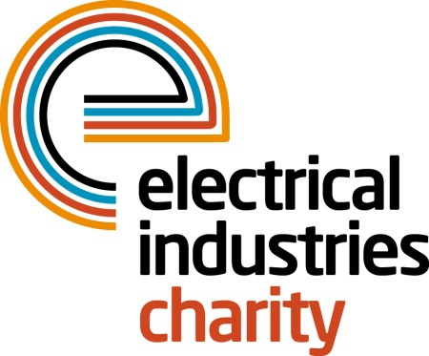
Press Release

14 November 2017

The Electrical Industries Charity welcomes Stuart Mackenzie as President

Stuart Mackenzie has become the new President of the Electrical Industries Charity. He succeeds former President and Chairman of Council, Paul Loke. Stewart Gregory will also join Stuart as the Charity’s Vice President.

Stuart has extensive electrical industry experience in different roles over a career period of 38 years. He started his career by joining one of the electrical wholesaler’s graduate programmes, before moving into manufacturing and progressing to the position of Managing Director of Dimplex and then Chairman of Glen Dimplex Heating & Ventilation.

Stuart has been a trustee for the Electrical Industries Charity for over seven years and has been involved in a wide range of the Charity’s fundraising events over the years.

In his new role, Stuart aims to bring more awareness of the Charity to every single part of the electrical sector and hopes to get everyone involved in extending the Charity’s support network.

The Charity’s new President, Stuart Mackenzie, says: “I am honoured to be elected as the Electrical Industries Charity’s President. I believe that the Charity is currently going in an excellent direction in helping those less fortunate than us in our sector.

“I believe that anyone who is working in any part of the electrical, electronics and energy-related sectors, should get involved in helping the Charity to create a bigger support network. Because we are all part of the electrical industry’s family and therefore it is crucial to help our colleagues and their families in their time of need.”

For further information, please contact Vicky Gray: vicky.gray@electricalcharity.org

www.electricalcharity.org

Note to editors
The Electrical Industries Charity is the national charity for the electrical, electronics and energy industries. It aims to look after people from these industries whenever they or their families need help with life’s challenges.

The charitable services are available to anyone who currently works or has worked in the very diverse and often converging industries, such as:
- Electrical contracting and facilities management
- Electrical and electronic manufacturing, wholesale, distribution and retail
- Electrical and mechanical engineering
- Lighting industry
- Generation, distribution and supply of electrical power, including nuclear and renewable energy

For further information about the Electrical Industries Charity please contact Keystone Communications:

Tracey Rushton-Thorpe Monika Gaubyte
Tel: 01733 294524 Tel: 01733 294524
Email: tracey@keystonecomms.co.uk Email: monika@keystonecomms.co.uk

