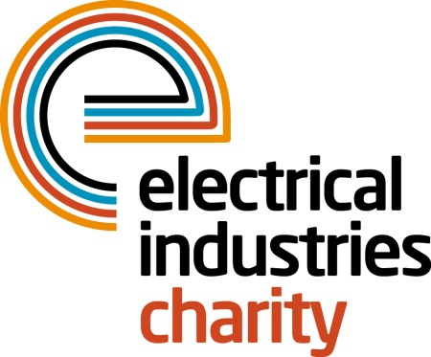
Press Release

22 January 2018

Play powerLottery and support thousands for just £1

The Electrical Industries Charity is offering you a chance to win big in 2018 with its very own powerLottery while helping thousands of elderly people in the electrical sector to have the retirement they deserve.

The Charity’s number one fundraising stream, powerLottery is offering everyone in the electrical sector a fun way to get involved in helping thousands of elderly people while being in with a chance of winning one of the 15 prizes of up to £1,000.

powerLottery accounts for 30% of the Charity’s annual income which is directly handed out in financial grants to the industry through the Charity’s Employee Assistance Programme of which the Pensioner Support Programme is part of.

Currently, in the UK there are over 11.8 million people aged 65 years and older of whom 1 million of them often feel lonely, and 1.4 million of them feel cut off from society.

Loneliness is a serious issue that often leads to mental health issues and can also increase the chance of premature deaths by as much as a quarter. A recent report by Age UK showed that nearly 1 million people aged 65 years old and over had to cut back on food shopping over recent years to cover the costs of utility bills. The same report also revealed that based on the 10-year average, this winter 28,600 older people are at risk of dying prematurely from the cold, due to a significant increase in poverty. This accounts for over 230 preventable deaths a day.

The power of £1 that you will pay to play the powerLottery will allow the Charity to provide vital support services to over 50,000 elderly people in the electrical sector through its Pensioner Support Programme. The Charity’s Programme offers free access to support services while also providing them with a way to connect with fellow retired colleagues.

Managing Director, Tessa Ogle says: “Our powerLottery is a fun way to win big prizes while changing the lives of the most vulnerable people in our sector. Anyone can sign up to play and help us to provide that crucial support for our retired colleagues for as little as £1 per entry.”

To enter the Charity’s powerLottery, please contact Vicky Gray: vicky.gray@electricalcharity.org or enter the draw through the Charity’s official website.

www.electricalcharity.org

Note to editors
The Electrical Industries Charity is the national charity for the electrical, electronics and energy industries. It aims to look after people from these industries whenever they or their families need help with life’s challenges.

The charitable services are available to anyone who currently works or has worked in the very diverse and often converging industries, such as:
- Electrical contracting and facilities management
- Electrical and electronic manufacturing, wholesale, distribution and retail
- Electrical and mechanical engineering
- Lighting industry
- Generation, distribution and supply of electrical power, including nuclear and renewable energy

For further information about the Electrical Industries Charity please contact Keystone Communications:

Tracey Rushton-Thorpe Monika Gaubyte
Tel: 01733 294524 Tel: 01733 294524
Email: tracey@keystonecomms.co.uk Email: monika@keystonecomms.co.uk

