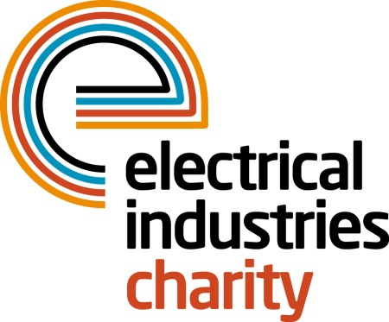
Press Release

19 October 2017

The power of a £1

The Electrical Industries Charity is challenging the 1.3 million people who work in our sector to give up just one cup of coffee every month and use the money to sign up for powerLottery instead.

The Charity’s number one fundraising stream, powerLottery is open to everyone and offers every participant the chance to win a cash prize of £1,000 every month. By signing up to play you will also be supporting a great cause because every £1 that you spend on powerLottery goes towards helping people in our industry with a hand up in their time of need.

The Lottery draws provide the Charity with 30% of its annual income which is directly handed out in financial grants to the industry through the Charity’s Employee Assistance Programme which include the Apprentice, Pensioner, Practical Participation and the Family and Employee Support Programmes.

The programmes are designed to offer people in our industry a hand up in their time of need through a wide range of services which include legal support, counselling, financial assistance and grants as well as carer support, debt advice, and apprentice scholarships and bursaries.

powerLottery is easy to enter, simply go to the Charity’s website and as soon as you fill in the online form you could be in with a chance of winning one of the monthly cash prizes. What’s more, if you sign up this month you could win the bonus prize of £5,000.

Managing Director, Tessa Ogle says: “powerLottery is a fun and easy way to support your industry Charity and help to provide access to a wide range of services for people in our industry when they are in need of support. By signing up to powerLottery you too can help your friends and industry colleagues, ensuring that no-one in our industry is ever alone in their time of need.”

If you want to test your luck at the Charity’s powerLottery and help to transform the lives of your colleagues and their families, please contact Vicky Gray: vicky.gray@electricalcharity.org or enter the draw through the Charity’s official website.

www.electricalcharity.org

Note to editors
The Electrical Industries Charity is the national charity for the electrical, electronics and energy industries. It aims to look after people from these industries whenever they or their families need help with life’s challenges.

The charitable services are available to anyone who currently works or has worked in the very diverse and often converging industries, such as:
- Electrical contracting and facilities management
- Electrical and electronic manufacturing, wholesale, distribution and retail
- Electrical and mechanical engineering
- Lighting industry
- Generation, distribution and supply of electrical power, including nuclear and renewable energy

For further information about the Electrical Industries Charity please contact Keystone Communications:

Tracey Rushton-Thorpe Monika Gaubyte
Tel: 01733 294524 Tel: 01733 294524
Email: tracey@keystonecomms.co.uk Email: monika@keystonecomms.co.uk

