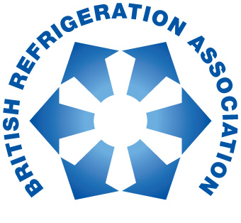

PRESS RELEASE: 30th January 2018

BRA releases PURR report second edition at HVACR Show

The British Refrigeration Association (BRA) has produced a second edition of its PURR report.

The updated edition was announced last week at the HVACR Show, which took place at ExCeL London. The first PURR (Putting into Use Replacement Refrigerants) report was produced in 2015 by members of BRA to help the industry meet some of the key implications and requirements of the EU F Gas regulation that came into force on 1st January 2015; in particular the urgent need to move away from high GWP refrigerants, such as R404A.

The second edition of the PURR report has been updated to reflect current market conditions, and contains several new features, including:
- Data on new A2L (low flammability) alternatives for R404A
- Data on R410A alternatives
- General information on the use of A2L refrigerants
BRA President John Smith says: “When we released the first PURR report two years ago it was welcomed by our members and the wider market as advice was sought in the wake of the F Gas Regulation announcement. The phase down is now well under way, and with less than two years left before the use and service bans on R404A take effect, we want to continue to give up to date guidance to all stakeholders involved in the commercial refrigeration market.

“This second edition of the PURR report provides greater clarity on alternative refrigerants, which should hopefully assist in ensuring a smooth transition for designers, manufacturers, installers, commissioners and end users to comply with the new enforcements.”

The report is available, free of charge, from the BRA section of the FETA website: www.feta.co.uk/associations/bra/publications

About BRA:

The British Refrigeration Association (B.R.A.) is the only trade association representing manufacturers, importers, wholesalers, distributors, contractors, specifiers and end-users of refrigeration plant, equipment and components.
It also includes producers of refrigerants and lubricants, colleges and training establishments. It works closely with government, public bodies and other organisations, both in the UK and overseas, to further the interests of the refrigeration industry. BRA was originally formed in 1940 under the name "Commercial Electric Refrigeration Association". It has worked continuously since 1940, as C.E.R.A., B.R.A., B.R.A.C.A and now again B.R.A. to promote the interests of the Refrigeration Industry.

For further information about BRA please contact Keystone Communications:

Russell Drury Michael Crane
Tel: 01733 294524 Tel: 01733 294524
Email: russell@keystonecomms.co.uk Email: michael@keystonecomms.co.uk

