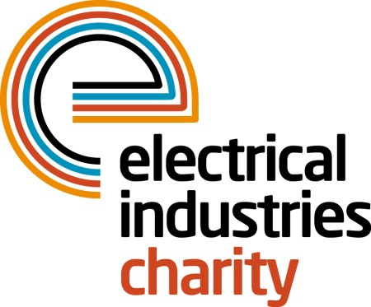
Press Release

06 February 2018

Raising the roof for the Dickinson family

powerBall 2017 brought together hundreds of industry professionals under one roof for the most unforgettable night in the electrical industry’s calendar and saw great support for the Raise the Roof campaign.

Raise the Roof – ‘One brick at a time’ aims to raise £250,000 to purchase a house for the Dickinson family and work with industry partners to carry out any renovation work which is required to safeguard the future of Caz Dickinson and her family.

On the night of powerBall, dozens of industry professionals donated hundreds of pounds each to the Electrical Industries Charity for personalised bricks that will help build the house foundation and walls for Caz and her family. A personalised brick allowed guests to put their names on this special project and their donation will serve as a long-lasting tribute.

Many companies participated on the night with the Big Build Project offering a wide range of their products and services that will help with all the necessary house renovations to safeguard Caz’s future independence.

Products and services donated on the night include lighting for all parts of the house by Collingwood Lighting and Zumtobel Group, and a voice lighting control system supplied by Saturn LED. A specialist bathroom suite was donated by Selco and all of the bathroom sanitary ware will be supplied by Wolseley.

Heat Mat will supply all the underfloor heating, with Heatrae Sadia and Baxi providing the rest of the house heating. Rexel kindly donated products required for the electrical wiring, Schneider Electric the consumer units, whilst Hager will be supplying the wiring accessories fitted by DJR Smith.

The smoke, heat and CO alarms have been taken care of by Kidde Safety and a full security technology enabled care system by Aico.

Other products which were donated on the night include kitchen units by Grafton Group Plc/Electricbase and cooking appliances by Glen Dimplex Kitchen Appliances; a Netatmo Smart Home system by City Electrical Factors (CEF) and a specialist vertical lifting carers bed by Eland Cables. The design and installation of all electrical and mechanical services will be provided by Synecore, who have also offered project management services and any other required work up to the value of £10,000. Further electrical labour will be supplied by SCV Electrical Limited. Any other specialist electrical equipment that may be needed will be covered by Edmundson Electrical.

Managing Director, Tessa Ogle says: “We would like to thank all of our supporters who have kindly donated to our Raise the Roof campaign. Without you, we would not be able to help those who are in need of our support.”

If you have not had a chance to be part of this special Big Build Project and would like to take part, you still can by getting involved and signing up to our Practical Participation Programme or by visiting the website to make a donation to the Raise the Roof campaign.

For further information, or to take part, please contact Vicky Gray: vicky.gray@electricalcharity.org

www.electricalcharity.org

Note to editors
The Electrical Industries Charity is the national charity for the electrical, electronics and energy industries. It aims to look after people from these industries whenever they or their families need help with life’s challenges.

The charitable services are available to anyone who currently works or has worked in the very diverse and often converging industries, such as:
- Electrical contracting and facilities management
- Electrical and electronic manufacturing, wholesale, distribution and retail
- Electrical and mechanical engineering
- Lighting industry
- Generation, distribution and supply of electrical power, including nuclear and renewable energy

For further information about the Electrical Industries Charity please contact Keystone Communications:

Tracey Rushton-Thorpe Monika Gaubyte
Tel: 01733 294524 Tel: 01733 294524
Email: tracey@keystonecomms.co.uk Email: monika@keystonecomms.co.uk

