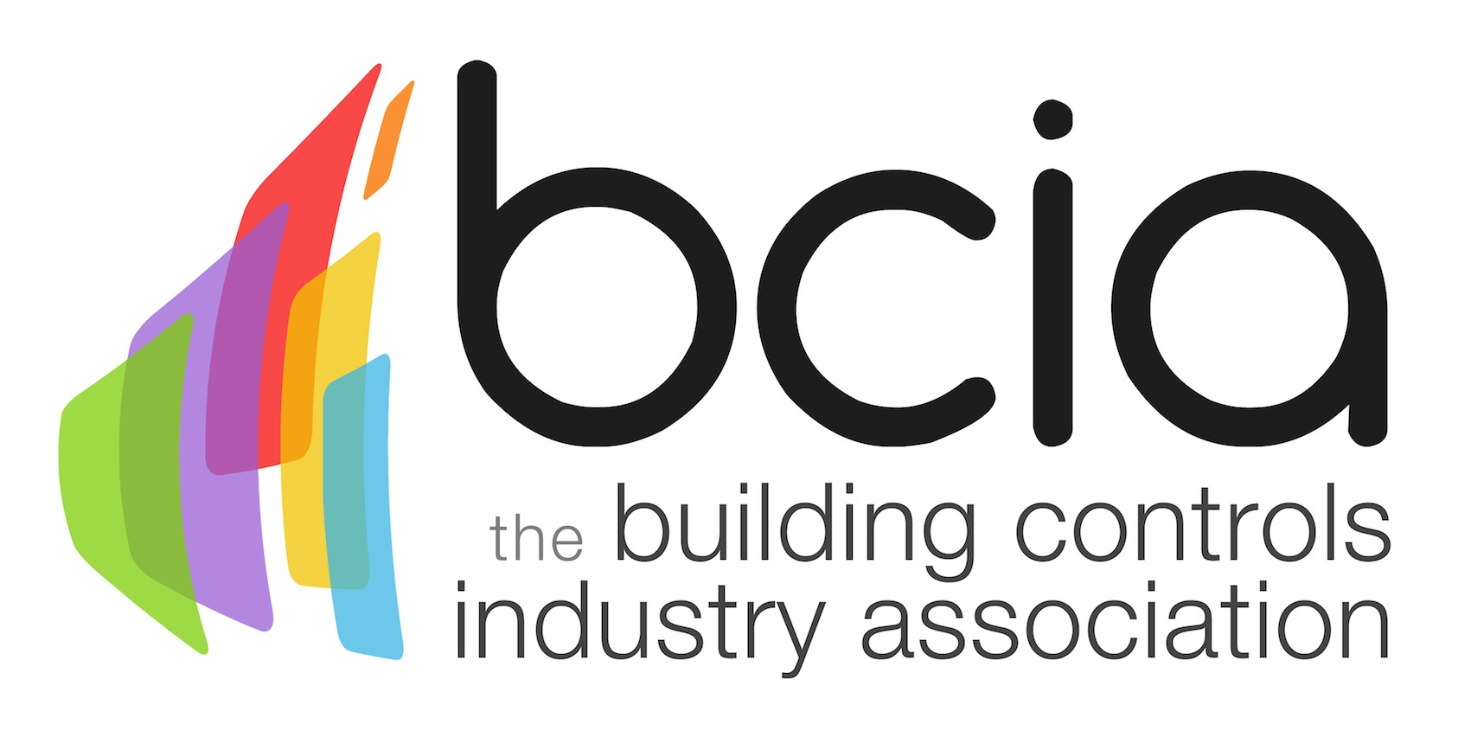

Press Release

07 February 2018

Change the future of building controls with new and improved BCIA training courses

Are you looking to learn more about the building controls industry? Or are you simply wanting to take your skills further and reshape the future of the dynamic controls sector? The Building Controls Industry Association (BCIA) has released more dates for its new BCM01-BCM06 training courses which are available throughout the year at various locations.

Engineers and technicians who are interested in upskilling their building controls knowledge can now book onto BCM01-BCM03 for the rest of the year, while those looking to book BCM04-06 can secure their places up to May 2018.

All six of the courses are CPD accredited by CIBSE. They have recently had a comprehensive update to ensure that engineers have up to date knowledge of the latest developments in the controls industry to gain the required skills and expertise to take the building controls sector to new heights.

Delegates who successfully complete the BCM01-03 courses will be awarded the Technical Certificate which will enable engineers to apply for the brand-new Building Controls Integrator ECS card.

The new ECS card allows control engineers to gain access to contracts and sites which specify ECS cards as mandatory, which gives them an advantage over competitors who can’t prove their accomplishments. The card is now available for applications via the ECS website.

What’s more, engineers who complete the BCM04-06 courses will be presented with the Advanced Technical Certificate. The qualification provides an opportunity to prove to clients and employers their full understanding of the six building controls subjects which cover Fundamentals of HVAC & Building Technology, Measuring & Control Technology, Hydraulics in Building Systems, Control Function in Heating Plant, Control of Ventilation and Air Conditioning Plant and Control of Cooling Systems.

Don’t miss your opportunity to gain world-class training on the latest technology in controls industry while taking your skills further for the exciting buildings of tomorrow. Places for BCM01-03 are filling fast. Book your place today to avoid disappointment.

Please contact Hayley Hopkins: training@bcia.co.uk for a full list of dates for BCM01-06 training courses or to book your courses today.

www.bcia.co.uk

Note to editors
The Building Controls Industry Association (BCIA) represents the UK building controls and BEMS sector. With around 75 members accounting for 70% of the UK controls market, the BCIA is an influential group that promotes better specification, application and use of controls. The BCIA also offers its own training courses and the Building Controls Professional Assessment (BCPA).

For further information about the BCIA please contact Keystone Communications:

Tracey Rushton-Thorpe
Tel: 01733 294524
Email: tracey@keystonecomms.co.uk

Leandra Graves
Tel: 01733 294524
Email: leandra@keystonecomms.co.uk

