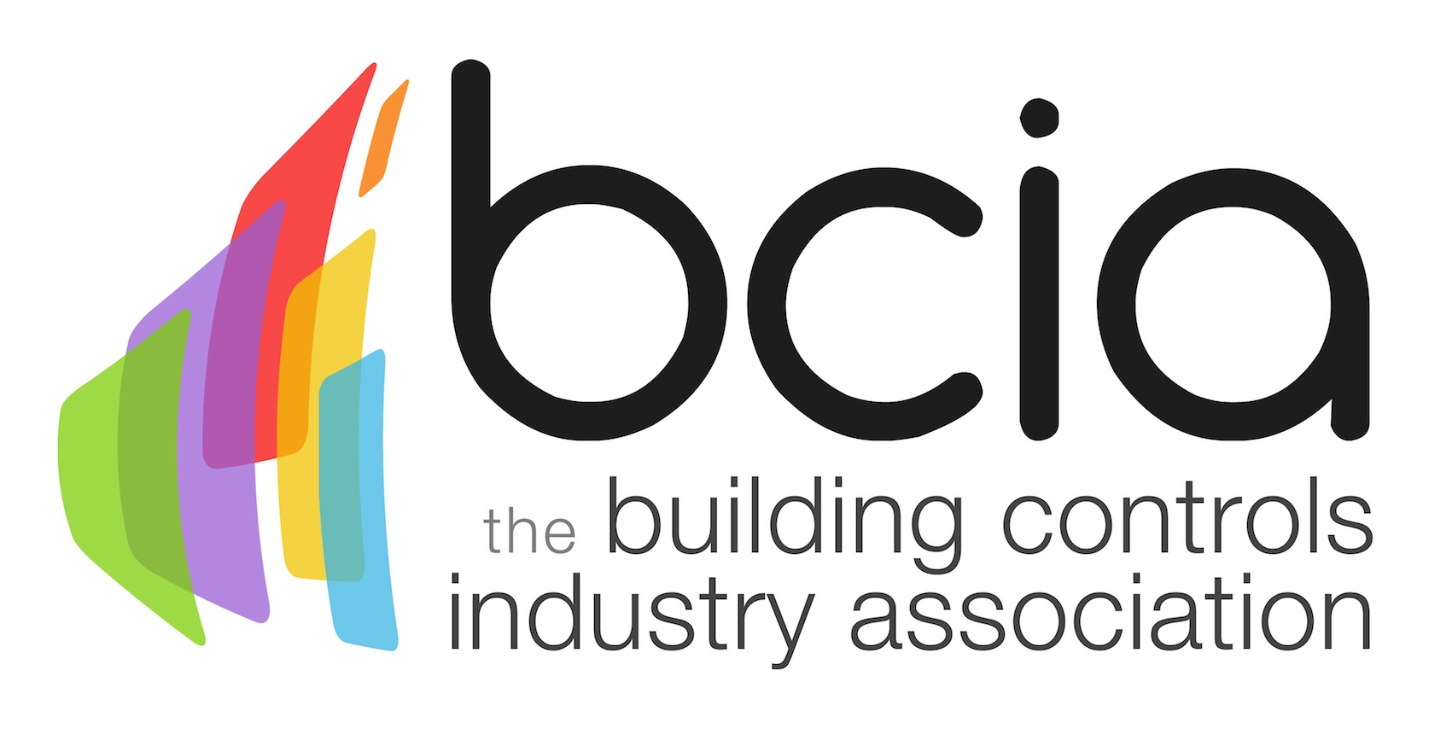

Press Release

19 March 2018

The BCIA Awards 2018 finalists announced

The Building Controls Industry Association (BCIA) is delighted to announce the finalists for the most prestigious industry awards ceremony – the BCIA Awards 2018.

This year’s leading industry awards received a record-breaking number of entries which showcased an increased standard of excellence across the sector. The judging panel had an extremely tough task to select the best candidates for each category and after much deliberation shortlisted 43 finalists in nine categories. The finalists are:

Independent Building Controls & BEMS Installer of the Year
Sponsored by CentraLine by Honeywell

Building Management Solutions Integrators (BMSI)
Chartwell Controls
Comfort Controls (Midlands) Ltd
Global Associates
Kendra Energy Solutions Ltd
SCS Group Ltd

Best Service & Maintenance Provider
Sponsored by Western Automation

AIS BMS
Comfort Controls Ltd
Demand Logic
Kendra Energy Solutions
Matrix Control Solutions
Pillinger Controls Ltd

Technical Innovation of the Year – Projects
Sponsored by Johnson Controls

Hilton Hotel, Room Energy Management Controls - Comfort Controls
Installation at 155 Moorgate - Demand Logic
University of Liverpool, Greenbank Student Village - Impact Control Systems
Bloomberg Connected Building - One Sightsolutions
Air Quality (AQ) Monitoring System - One Sightsolutions
Urban Science Building, Newcastle - Matrix Control Solutions/En Tech

Technical Innovation of the Year - Products
Sponsored by BCIA

ACIS T4TWDS, Tier 4 Treated Water Distribution System – Airedale International Air Conditioning
Chartwell Secure - Chartwell Ltd
Global spaces - Global Associates
Bubll - Econowise Drives & Controls
BCM Building Control Module - iaconnects Ltd
Desigo DXR terminal unit controller - Siemens Building Technologies

Energy Management Award
Sponsored by Priva

Mace at 155 Moorgate, London – Demand Logic
Inverter & BMS upgrade at University of Westminster - Global Associates
Project Aether at Pets at Home - Ignite Energy
AXON Implementation at London Bridge City - Next Control Systems
E. ON’s business energy efficiency specialists working with Tesco Stores Ltd - Matrix Control Solutions
London School of Economics - Portal Building Controls

Contribution to Training Award
Sponsored by Siemens Building Technologies

Acuity Brands Lighting/Distech Controls
Gemco Intelligent Buildings Group
One Sightsolutions Ltd
The Sontay Academy

Engineer of the Year
Sponsored by Trend Control Systems

Andy Kempton– Comfort Controls
Mark Johnson – Chartwell Controls
John Mogg - Building Management Solutions Integrators (BMSI)
David Grinsted - Kendra Energy Solutions
Tony McDermott - Laplace Solutions
Stuart Young - Schneider Electric
Miles Moss – Detail Design Engineering

Young Engineer of the Year
Sponsored by BCIA

Joshua Austin – Global Associates
Abi Pullin - Matrix Control Solutions
Gregory Smith - Matrix Control Solutions

Jon Belfield, President of the BCIA, says: “The quality of this year’s entries is exceptionally high and showcases excellence across our sector. The three defining features across all categories are innovation, investment and training. On behalf of the BCIA, thank you to everyone who has entered and congratulations to all of this year’s finalists. I look forward to seeing you all at the awards ceremony in May.”

The winners will be announced at the prestigious BCIA Awards ceremony which will be held on Thursday 10 May 2018 at the Hilton Birmingham Metropole. Book your tickets today and find out who will be named the best in the building controls industry.

For further information or to book your ticket today, please contact Hayley Hopkins: hayley@keystonecomms.co.uk

https://bcia.co.uk

Note to editors
The Building Controls Industry Association (BCIA) represents the UK building controls and BEMS sector. With around 75 members accounting for 70% of the UK controls market, the BCIA is an influential group that promotes better specification, application and use of controls. The BCIA also offers its own training courses and the Building Controls Professional Assessment (BCPA).

For further information about the BCIA please contact Keystone Communications:

Tracey Rushton-Thorpe
Tel: 01733 294524
Email: tracey@keystonecomms.co.uk

Leandra Graves
Tel: 01733 294524
Email: leandra@keystonecomms.co.uk

