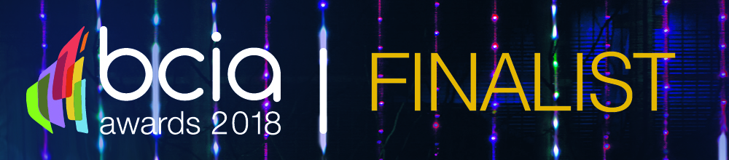 

**Press Release**

**9th March, 2018  
FOR IMMEDIATE RELEASE**

**Building Control Module from IAconnects Technology shortlisted in BCIA Awards 2018**

IAconnects Technology Ltd, an integration partner of Beckhoff Automation, has been shortlisted for an award at the 2018 BCIA Awards taking place in May. The company’s Building Control Module (BCM) was nominated in the ‘Technical Innovation of the Year’ category.

Unlike a conventional lighting control module (LCM) which only controls lighting, the plug and play multi-master BCM allows quick and easy connectivity of all DALI devices with power, data and, optionally, power plus analogue and digital IO for control of fan coil units, chilled beams and re-heater batteries. Each BCM has an on-board EnOcean transceiver, on-board Wi-Fi and can be networked via Ethernet or EtherCAT with standard Cat5e cables and connectors.

The on-board CPU running IA’s MobiusFlow software allows the user to browse the BCM and configure luminaires and wired or wireless switches, sensors and actuators independently of a network connection, with control regimes easily defined via the Node-RED drag-and-drop environment. This means that on large scale projects commissioning is localised and there is no need for IT infrastructure to be in place before control is applied, removing the typically back-end loaded nature of delivery.

David Lister, Managing Director at IA Connects Technology commented, “Among the BCM’s most appealing aspects are its simplicity and flexibility. We believe the industry needs products that allow commissioning and control modifications to be executed by all of the stakeholders throughout the CapEx and OpEx phases of a building’s life. We need to remove the dependency on specialist and typically expensive commissioning services, and yet still ensure systems are compliant. The feedback from clients has been excellent so far and we are delighted to be nominated for this award.”

The biggest and best Awards in the controls and BEMS industry, the BCIA Awards recognise innovation, product development, project delivery and great training in the building controls sector. The 2018 Awards will be held on Thursday 10th May 2018, at the Hilton Birmingham Metropole.

[**www.iaconnects.co.uk**](http://www.iaconnects.co.uk)

**Editor’s Notes**

**IA**connects is a technology company that specialises in creating, delivering and commissioning advanced building control systems and asset management systems to provide energy efficient operation along with intelligent diagnostics, resulting in optimum savings for the building operator.

**For further information, please contact Keystone Communications:**

Michael Crane

Tel: 01733 294524

Email: michael@keystonecomms.co.uk