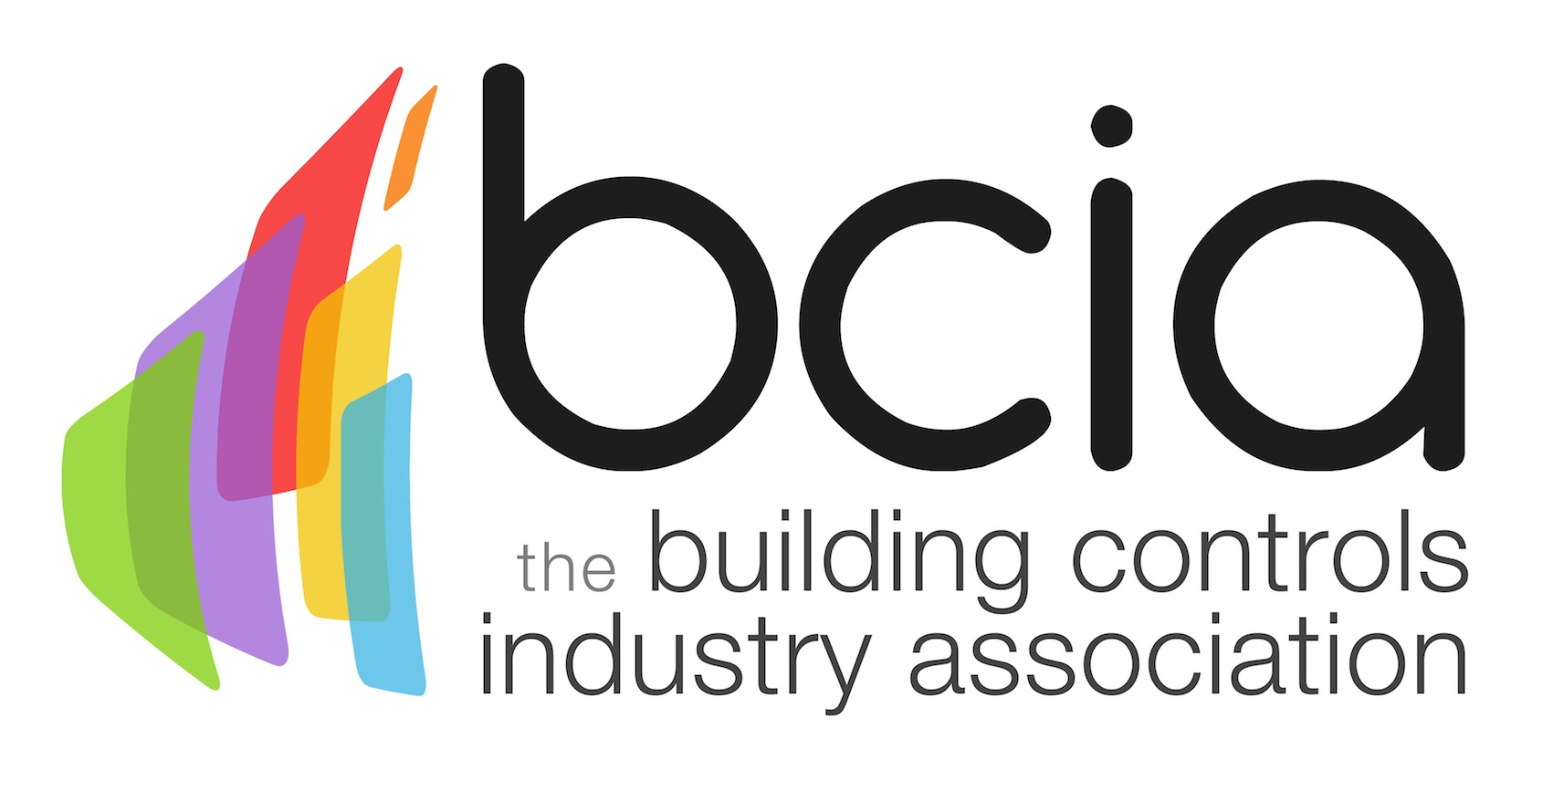

Press Release

11 April 2018

Final chance to secure your place for the BCIA Awards 2018

Tickets are selling fast for the highly anticipated Building Controls Industry Association (BCIA) Awards. Book your table today to champion the industry’s finest success while discovering the latest innovations and projects that are redefining the future of the building controls industry.

This year’s prestigious industry event will be hosted by the multi-award-winning comedian, writer and actor Lucy Porter. Guests will have a memorable night with a wide range of entertainment available throughout the evening. This unmissable glitzy BCIA Awards ceremony and gala dinner is taking place on Thursday 10 May 2018 at the Hilton Birmingham Metropole.

You will have a chance to test your luck at the casino, showcase your competitive streak on the Giant Scalextric and have an opportunity to take home some wonderful prizes by participating in the Head and Tails game.

The BCIA Awards will also present guests with an opportunity to change thousands of men’s lives by donating money to Prostate Cancer UK, which is the President’s chosen charity.

If you want to find out who will be revealed as the lucky nine winners at this year’s awards ceremony, book your place now, to avoid disappointment as there are only limited spaces available. You can book a table of ten for just £1,100 or secure an individual place for £130.00. To book your spaces, visit the BCIA website today and download a booking form.

To book your place, please contact Hayley Hopkins: hayley@keystonecomms.co.uk

https://bcia.co.uk/awards/

Note to editors
The Building Controls Industry Association (BCIA) represents the UK building controls and BEMS sector. With around 75 members accounting for 70% of the UK controls market, the BCIA is an influential group that promotes better specification, application and use of controls. The BCIA also offers its own training courses and is currently supporting a new Trailblazer Apprenticeship Standard for the industry which is being developed by the BEMS Employer Group.

For further information about the BCIA please contact Keystone Communications:

Tracey Rushton-Thorpe
Tel: 01733 294524
Email: tracey@keystonecomms.co.uk

Leandra Graves
Tel: 01733 294524
Email: leandra@keystonecomms.co.uk

