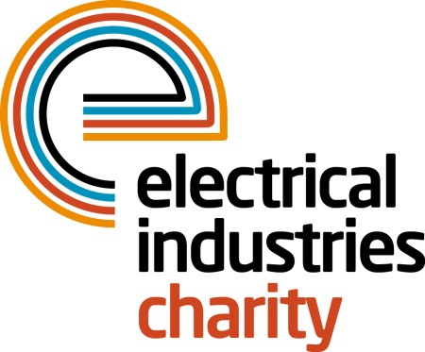
Press Release

19 April 2018

New Programme Manager for the Big Build project

The Electrical Industries Charity welcomes Claire Shelton as the new Programme Manager for the Big Build project which aims to transform the future of the Dickinson family.

Claire has extensive experience of working in frontline support services and helping people with a wide range of issues including housing issues, debts and benefits management and mental health problems. Claire has also won the ‘Wow!’ You’ve made a difference Award in 2017 at the Wow! Gala Ceremony for her outstanding work in her previous role as an Outreach Officer.

In her new role, Claire will be continuing to bring success with the Big Build project while maintaining the wellbeing and welfare of the Dickinson family throughout the journey.

Claire Shelton says: “I am thrilled to take on such a rewarding job role. This new role is something that I always aspired to do. I am also looking forward to working with such an inspiring Charity which continues to find unique ways to make a positive change to the lives of people in our industry.

“I am looking forward to starting work on this incredible project, and with many years of experience, I believe that I will be able to make a real difference in the Dickinson family’s life. I will also provide all of the in-house support and will look after their well-being and welfare throughout their journey because nothing is impossible if you think outside of the box.”

So far, the Charity has had huge support from the industry for the Big Build project with numerous companies offering their products and services that will help with all of the necessary house adaptations which are needed to help with Caz’s development and care.

Companies who have donated their products and services so far, include Collingwood Lighting, Zumtobel Group, Saturn LED, Selco, Wolseley, Heat Mat, Heatrae Sadia, Baxi, Rexel. Also, Schneider Electric, Hager, DJR Smith, Kidde Safety, Aico, Grafton Group Plc/Electricbase, Glen Dimplex Kitchen Appliances, City Electrical Factors (CEF), Eland Cables. Other companies who also donated were Synecore, SCV Electrical Limited and Edmundson Electrical.

If you have not had a chance to show your support for this incredible family, you can still do so by joining the Charity’s Practical Participation Programme today, or you can donate via the Charity’s official website: https://www.electricalcharity.org/index.php/fundraising/challenge-for-a-cause/2017-2018

For further information, please contact Vicky Gray: vicky.gray@electricalcharity.org

www.electricalcharity.org

Note to editors
The Electrical Industries Charity is the national charity for the electrical, electronics and energy industries. It aims to look after people from these industries whenever they or their families need help with life’s challenges.

The charitable services are available to anyone who currently works or has worked in the very diverse and often converging industries, such as:
- Electrical contracting and facilities management
- Electrical and electronic manufacturing, wholesale, distribution and retail
- Electrical and mechanical engineering
- Lighting industry
- Generation, distribution and supply of electrical power, including nuclear and renewable energy

For further information about the Electrical Industries Charity please contact Keystone Communications:

Tracey Rushton-Thorpe Monika Gaubyte
Tel: 01733 294524 Tel: 01733 294524
Email: tracey@keystonecomms.co.uk Email: monika@keystonecomms.co.uk

